s./

**Learning Report – Evolved MBSE**

**MINIPROJECT-AUTOMOTIVE**

Course Code: <CODE>



Version Number:

Team Members :

Team No:

Module: Model Based System Engineering

|  |  |  |  |  |  |
| --- | --- | --- | --- | --- | --- |
| **Ver. Rel. No.** | **Release Date** | **Prepared. By** | **Reviewed By** | **Approved By** | **Remarks/Revision Details** |
| 1.1 | 20-03-2021 | Nilanjana Das | Prateek Chauhan | Prithvi Shekhar | Wiper system MBSE |
| 1.2 | 21-03-2021 | Nilanjana Das | Prateek Chauhan | Prithvi Shekhar | Wiper system logic update |
| 1.3 | 22-03-2021 | Nilanjana Das | Prateek Chauhan | Prithvi Shekhar | Wiper system labelling |
| 1.4 | 23-03-2021 | Nilanjana Das | Prateek Chauhan | Prithvi Shekhar | Wiper system total updated |
|  |  |  |  |  |  |
| 1.1 | 20-03-2021 | Aryan Verma | Darpan Patil | Prithvi Shekhar | Safety blind MBSE |
| 1.2 | 21-03-2021 | Aryan Verma | Darpan Patil | Prithvi Shekhar | Safety blind labelling |
| 1.3 | 22-03-2021 | Aryan Verma | Darpan Patil | Prithvi Shekhar | Safety blind MBSE logic update |
| 1.4 | 23-03-2021 | Aryan Verma | Darpan Patil | Prithvi Shekhar | Safety blind total updated |
|  |  |  |  |  |  |
| 1.1 | 20-03-2021 | Prateek Chauhan | Nilanjana Das | Prithvi Shekhar | Cruise control system MBSE |
| 1.2 | 21-03-2021 | Prateek Chauhan | Nilanjana Das | Prithvi Shekhar | Cruise control system labelling |
| 1.3 | 22-03-2021 | Prateek Chauhan | Nilanjana Das | Prithvi Shekhar | Cruise control system MBSE updating |
| 1.4 | 23-03-2021 | Prateek Chauhan | Nilanjana Das | Prithvi Shekhar | Cruise control system updated |
|  |  |  |  |  |  |
| 1.1 | 20-03-2021 | Darpan Patil | Sharath Saunshi | Prithvi Shekhar | Tire pressure updated |
| 1.2 | 21-03-2021 | Darpan Patil | Sharath Saunshi | Prithvi Shekhar | Tire pressure updated |
| 1.3 | 22-03-2021 | Darpan Patil | Sharath Saunshi | Prithvi Shekhar | Tire pressure updated |
| 1.4 | 23-03-2021 | Darpan Patil | Sharath Saunshi | Prithvi Shekhar | Tire pressure updated |
|  |  |  |  |  |  |
| 1.1 | 20-03-2021 | Sharath Saunshi | Aryan Verma | Prithvi Shekhar | Airbag system report evolving |
| 1.2 | 21-03-2021 | Sharath Saunshi | Aryan Verma | Prithvi Shekhar | Airbag system updated |
| 1.3 | 22-03-2021 | Sharath Saunshi | Aryan Verma | Prithvi Shekhar | Airbag system labelling |
| 1.4 | 23-03-2021 | Sharath Saunshi | Aryan Verma | Prithvi Shekhar | Airbag system report done |

**Document History**

# 

Contents

1. INTRODUCTION: 4

**1.1.** **MANUAL WIPER CONTROL SYSTEM** 4

**1.2.** **SAFETY BLIND ZONE:** 5

**1.3.** **CRUISE CONTROL** 5

**1.4.** **AIR BAG** 5

**1.5.** **TIRE-PRESSURE MONITORING SYSTEM (TPMS)** 6

**1.6.** **SUMMARY OF FEATURES USED** 7

2. RESEARCH: 7

**2.1.** **Literature Survey** 7

2.1.1. Manual Wiper System: 7

2.1.2. Cruise Control System 8

2.1.3. Air Bag: 9

2.1.4. Safety Blind zone: 9

2.1.5. TPMS: 9

**2.2.** **ALGORITHM:** 11

3. SWOT ANALYSIS: 34

4. DESIGN: DETAILED REQUIREMENTS 35

**4.1.** **High Level Requirements** 35

**4.2.** **Low Level Requirement:** 36

5. TEST CASES: 37

**5.1.** **HIGH Level Test Plan:** 37

**5.2.** **Low Level Test Plan:** 40

6. COMPLIANCE REPORTS 43

**6.1.** **MCDC Coverage report** 43

**6.2.** **MODEL ADVISORY REPORT** 45

**Table of Figures**

# Figure1 Wiper system………………………………………………………………………………………………………………………………………...4

**Figure2 Airbag system………………………………………………………………………………………………………………………………………..5**

**Figure3 Tyre pressure monitoring system**……………………………………………………………………………………………**6**

**Figure4 Flowchart of manual wiper system………………………………………………………………………………………………………..7**

**Figure5 Algorithm of manual wiper system………………………………………………………………………………………………………..8**

**Figure6 Algorithm of working of blind spot detection………………………………………………………………………………………..9**

**Figure7 Algorithm of working of Cruise Control…………………………………………………………………………………………………10**

**Figure8 Algorithm of working of Air Bag system………………………………………………………………………………………………..11**

**Figure9 Algorithm of working of TPMS system………………………………………………………………………………………………….12**

**Figure10 Model diagram of wiper system……………………………………………………………………………………………………………13**

**Figure11 Gear motor for wiper……………………………………………………………………………………………………………………………14**

**Figure12 Permanent Magnet Motor for wiper…………………………………………………………………………………………………….15**

**Figure13 Datasheet of Gear motor for wiper………………………………………………………………………………………………………16**

**Figure14 Automotive Silent Relay………………………………………………………………………………………………………………………17**

**Figure 15 Cruise Control state Transition diagram………………………………………………………………………………………………..18**

**Figure 16 Cruise Control system architecture ……………………………………………………………………………………………………….15**

**Figure 17 Cruise Control dimensions……….…..……………………………………………………………………………………………………….16**

**Figure 18 Working of Blind spot detection….……….……………………………………………………………………………………………….17**

**Figure 19 QT50R Specification Table……….…………………………………………………………………….………………………………………18**

**Figure 20 S240RA Specific Table……………………………………………………..….…………………………………………………………………18**

**Figure 21 Working of Accelerometer…………. ………….…………………………………………………………………………………………….19**

**Figure 22 Opamp………………………………………..………………………………………………….…………………………………………………….20.**

**Figure 23 Datasheet of accelerometer….………………….………………………………………….……………………………………………….29**

**Figure 24 Seat occupancy sensor……………………………………….………………………………..……….………………………………………30**

**Figure 25 Seat occupancy sensor datasheet…………………………………..……………………….…………………………………………….30**

**Figure 26 Seat belt tension sensor..…………. …………………………………………………………….……………………………………………31**

**Figure 27 Pressure sensor…………………………..………………………………………………………….…………………………………………….32**

**Figure 28 Pressure sensor overview….….…………………………………………………………………….………………………………………..33**

**Figure 29 Pressure Calculation….……………………………………….………………………………………,.……………………………………….34**

**Figure 30 Automated model of BCM Module………………………………………………………………………………………………………….46**

**Figure 31 Manual model of BCM Module……………………………………………………………………………………………………………….46**

**Figure 32 Coverage analysis …………………….…………………………………..……………………………..……………………………………….45**

**Figure 33 Coverage report….……………………………………….……………………………………………….……………………………………….45**

**Figure 34 MCDC coverage report summary of child systems……………………………………………………………………………………48**

**Figure 35 Model advisor reports .…………….…………………………………..…………………………..………………………………………….49**

**List of tables:**

**Table 1 Comparison table for 2 types of motor………………………………………………………………………….……………………..20**

**Table 2 Coil data for the relay……………………………………………………………………………………………………….………………….20**

**Table 3 Throttle Sensor Comparison……………………………………………………………………………………….………………………..22**

**Table 4 Throttle Sensor parameters……………………………………………………………………………………………………….…………22**

**Table 5 Electronic Speedometer Parameters……………………………………………………………………………………….……………24**

**Table 6 Hella77ghz Specification Table…………………………………………………………………………………………….…..............28**

**Table 7 Sensor Comparison…………………………………………………………………………………………………………….………………..28**

**Table 8 SWOT Analysis……………………………………………………………………………………………………………………..……………..36**

# INTRODUCTION:

## **MANUAL WIPER CONTROL SYSTEM**

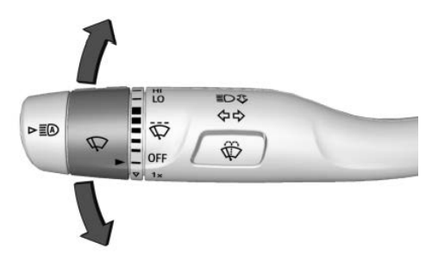

**Figure 1: Wiper system**

[Source: GMC Sierra Manual]

The main purpose of the wiper system is to clean the windscreen sufficiently to provide suitable visibility at all times. The wiper system must perform the following tasks.

(a) Efficient removal of dirt, water and snow.  
(b) Operation in the temperature range of 243 K to 353 K.  
(c) The ability to pass the stall and snow load test.  
(d) A service life of around 1500 000 wipe cycles,

(e) Resistance to corrosion from acid, alkalis and ozone.

For meeting the above requirements, proper design and manufacturing with good quality components are required for both the wiper and washer systems. The actual method of cleaning the screen by the blades can vary provided that the legally prescribed area of the screen is cleaned.

Car used for reference: **GMC SIERRA 2020**

## **SAFETY BLIND ZONE:**

With more than 1 million annual road fatalities worldwide, safety has become a key focus for the whole automotive industry. In Europe, the New Car Assessment Program (NCAP) is encouraging OEMs to adopt advanced driver-assistance systems (ADAS) in all new cars by implementing stringent safety requirements. Combined sensor inputs bring more accurate and reliable information on the car surroundings, allowing the control unit to take preventative or corrective actions with, for instance, warning and haptic feedback, or emergency braking and steering, respectively. These sensors include radar, cameras, LiDAR, and ultrasonic. Each brings their strengths and limitations to the table.

The 79-GHz frequency combines a better form factor with 3X smaller antennas and benefits from a wide frequency band of 4 GHz (77 to 81 GHz). This opens the opportunity for high-resolution radar, which is critical for autonomous cars. On the contrary, 24-GHz operation in ultra-wideband (21.65 to 26.65 GHz) will be forbidden in Europe as of 2022, restricting the 24-GHz usage to ISM narrowband (24.05 to 24.25 GHz).

## **CRUISE CONTROL**

Cruise control utilizes a clever system that regulates your engine to keep your car driving at a set speed. It's a system one manually activates, and when you do it takes control of the accelerator and adjusts the power input automatically to maintain the speed you select - it will even sense when you're going up hills and deliver more power when necessary.

Cruise control comes in SAE level 1 in which the driver will be able to set the current speed by pressing a button on the dashboard and cancel in anytime it wants to by pressing the cancel button. Driver can reduce and increase the speed of the vehicle by pressing -ve and +ve button. Adaptive cruise control comes into SAE level 2 in which the vehicle can adapt the speed of vehicle ahead of it. In Level 3 the adaptive cruise control comes with lane centering feature and both the features are merged.

The report has the research about the components needed in the system and analysis of the components using data sheet. SWOT analysis of the model is done. The High level and low-level requirements are mentioned with the test plans.

## **AIR BAG**

The AIRBAG is the vehicle safety device to protect the driver and passenger from striking the steering wheel or a window.  The airbag is designed to only inflate in moderate to severe crashes. Front airbag may deploy to help protect occupants in side impacts if there is sufficient forward movement during the crash. The driver airbag is located in the steering wheel. The passenger airbag is located in the dashboard.

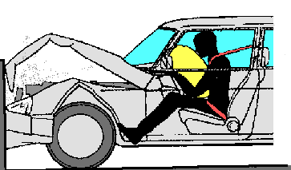

**Figure 2: Airbag system**

[Source: <https://www.aa1car.com/library/airbag_crash.gif>]

During a crash, the vehicle's crash sensors provide crucial information to the airbag electronic controller unit (ECU), including collision type, angle, and severity of impact. Using this information, the airbag ECU's crash algorithm determines if the crash event meets the criteria for deployment and triggers various firing circuits to deploy one or more airbag modules within the vehicle. Working as a supplemental restraint system to the vehicle's seat-belt systems, airbag module deployments are triggered through a process that is designed to be used once. Newer side-impact airbag modules consist of compressed-air cylinders that are triggered in the event of a side-on vehicle impact.

## **TIRE-PRESSURE MONITORING SYSTEM (TPMS)**

A tire-pressure monitoring system (TPMS) is an electronic system designed to monitor the air pressure inside the pneumatic tires on various types of vehicles. A TPMS reports real-time tire-pressure information to the driver of the vehicle, either via a gauge, a pictogram display, or a simple low-pressure warning light.  TPMS are provided both at an OEM (factory) level as well as an aftermarket solution.

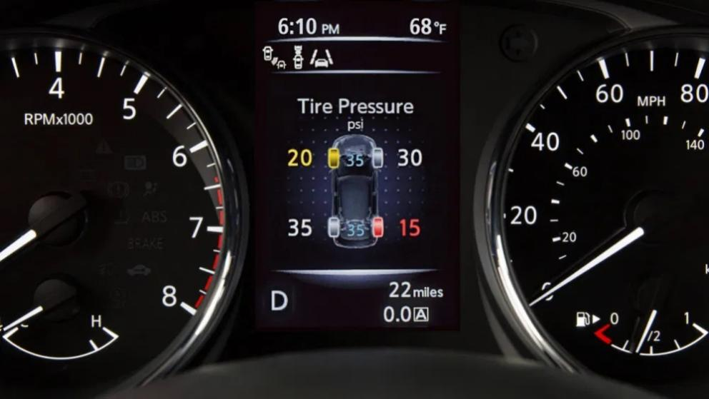

**Figure 3: Tyre pressure monitoring system**

## **SUMMARY OF FEATURES USED**

The features implemented by our group is cruise control, Tyre pressure monitoring system, manual wiper system, safety blind zone, airbag. The assumptions taken for the wiper system is that rear wiper is not included in the model implementation, if the airbag is deployed all features will continue to work, image processing feature is not being implemented in the safety blind zone, individual pressure display in Tyre pressure monitoring system is the last one that hasn’t been taken into consideration.

# RESEARCH:

## **Literature Survey**

### Manual Wiper System:

* In the literature study, it is seen that various sensors are used for detection of raindrops. Ashik K.P and A. N. Basavaraju have been worked on automatic wipers with Mist control. They used beaker to collect the rainwater and according to the level of collected water the speed of motor is controlled.
* Mukul Joshi et al worked on modified and cost-effective automatic wiper control system. PIC Micro-controller is used to process the signal received from rain drop sensor.
* Hyundai: kia America Technical Centres’ design team worked on new rain sensing system for wiper control based on capacitive sensor technology. Capacitive sensing relies on interactions with an emitted electric field to determine the presence of water drops/ object.
* H Kajioka et al have developed an optical automatic wiper system using rain sensor. An optical sensor is used to detect the rainwater. LED and LDR are used for detection of raindrops. The degree of rain fall is determined by the frequency of change in intensity of received light.
* N Prabhakaran proposed an efficient low-cost wiper system for autonomous vehicles. Here, Atmega8 /microcontroller to control the movement of wiper. Plate based water sensor is used to detect the raindrops.

[**Reference**: <https://www.ijraset.com/fileserve.php?FID=22059>]

### Cruise Control System

* The current scenario where driver error is the most common cause of traffic accidents can be improvised greatly using SDV technology. SDV cars utilize computational algorithms, sensors, and communication devices to automatically navigate a variety of environments without human drivers. SDV technology has the potential to radically transform our transport system, improving our living environment. In mid-October 2015, Tesla motors announced that all its new cars would be outfitted with equipment that would allow them to drive on their own, confirming that all TESLA vehicles will have the hardware needed for full self-driving capability at a safety level substantially greater than that of a human driver. Various perspectives from social justice and ethics show that SDVs lead to profound consequences for users and societies which must be considered greatly. To address these challenges, a framework for a more ethical design practice for SDV systems must be addressed, steering current engineering practices on SDV technologies away from a narrow, technical perspective, taken into consideration, social concerns and ethical investigations.
* Road weather events increase both travel time and crash risk, which results in a surface transportation system with compromised reliability. Crash frequencies increase significantly during inclement road weather conditions, although traffic demand is far lower than in normal conditions. ITS infrastructures are advanced applications, most widely used to inform motorists about current and future traffic conditions, which help travelers to make informed decisions in route selection and another pre-trip planning. ITS aims to provide innovative services relating to different modes of transport and traffic management and enable various users to be better informed and make safer, more coordinated, and smarter use of transport networks. The U.K. has installed a set of road weather radars to collect real-time radar imagery to develop a maintenance program and reported improvement in maintenance planning. Sweden has been piloting the use of floating car sensor data to combine with RWIS data for winter maintenance planning. Further study in the field of automated vehicles leads to the analysis of vehicular platooning concept. A group of coordinated vehicles is called a platoon.
* Advanced driver assistance systems (ADASs), are automotive systems designed to assist in all aspects of driving, including safety, drivability, and fuel economy. Examples of ADA systems are various forms of cruise control, lane-keeping systems, and collision-warning systems. The implementation of ADAS may lead to a fatality decrease of 40%. Innovative Advanced Driver Assistance Systems help drivers stay on top of things, helping them arrive safe and relaxed. The Car TALK 2000 project focuses on developing cooperative driver-assistance systems, which are based upon mobile, inter vehicle communication. The traffic impacts of two applications, which are basic warning function and early braking, were assessed using MIXIC model. The MIXIC model is a stochastic simulation model in which all the required considerations for assessing the impacts on traffic performance, traffic safety, exhaust-gas emission, and noise emission.

[**Reference Link for Literature survey**: <http://www.ijlera.com/papers/v2-i3/part-II/29.201703112.pdf>]

### Air Bag:

* An airbag is an automotive safety equipment which is used to save lives of the drivers as well as the passenger during a crash. The purpose of an airbag is to cushion occupants during a crash and provide protection to their bodies when they strike interior object such as steering interior wheel or window, etc. Thus, the usage of airbag system lowers the number of injuries by reducing the force exerted by steering wheel, windows, and dashboard at any point on the body. Many researches are going on to develop the features of the airbag.
* Accelerometer sensor is used to read the collision detection and give output in terms of voltage change to the system and forces the system to airbag deploy. Basically, it senses the sudden deceleration of the system during a crash.

[**Reference Link for Literature survey**: <http://www.ijlera.com/papers/v2-i3/part-II/29.201703112.pdf>]

### Safety Blind zone:

* In the previous technology we use ultrasonic sensor which uses sound wave for the detection of the vehicle, but now more reliable radar sensor is used to the do the task which provide large azimuthal angle which provide large coverage area of about 120.
* We can use image processing for the detection of the vehicle, but that technology is not evolved to such large extent as the safety of the driver is compromised because failure of the system can cause the catastrophic damage to the property as well as to the human life.

[**Reference Link for Literature survey**: <https://vzan.org/driving-technology/radar-based-blind-spot-monitoring-> ]

### TPMS:

Basically, there are 2 types of TPMS:

* Indirect tire pressure monitoring system which uses wheel speed sensors to calculate the pressure inside the tire.
* Direct tire pressure monitoring pressure which uses the pressure sensors to calculate it directly.

Benefits of TPMS:

* Fuel Savings.
* Extended Tire life.
* Improved safety.
* Environmental efficiency.

**[Reference Link for Literature survey:** https://www.erpublication.org/published_paper/IJETR042005.pdf]

**Study on Feature: Wiper system**

**Wiper Motor Permanent-magnet Type.** The construction of a single speed motor is shown. The armature with 8-slots is mounted on self-lubricating sintered bushes. Two carbon brushes, set 180 degrees apart, rub on an 8-segment commutator generally installed at the driving end. Two strong permanent magnets are bonded to the steel yoke using an adhesive, which is sometimes coated externally with non-ferrous metal to protect it against corrosion. A steel worm, formed on the end of the armature, drives a plastic worm wheel at a speed of about l/10th the speed of the armature.

**Shunt Wound Motors.** These motors are rarely used nowadays due to the superiority of the permanent magnet type in respect of power, noise, efficiency, cost, reliability, and current consumption. Figure 30.6A shows the layout of a single speed motor using a shunt wound field.

**Self-parking Wipers.** On some vehicles the wiper blades are parked off the windscreen. To achieve this arrange­ment the circuit is switched-on so that the current through the armature is reversed after the motor has stopped. This change the polarity of the brush in the permanent magnet motor so that the armature rotates in the opposite direction. By arranging the gearbox linkage, the wiping stroke can be extended by the reverse motion, and this movement parks the wiper blades away from the glass screen.  
Overload Protection. During snow or ice conditions the load on the wiper motor increases heavily, which decreases motor speed and under extreme conditions stops it. The decrease in armature speed reduces back emf due to which is large current in the order of 11A flows through the motor leading to overheating and possible damage to the motor.

**Washers** As per the statutory regulations in some countries a screen washer must be installed to clean the driver’s side of the Windscreen. Most of the vehicles install an electrically operated pump to supply water or cleaning fluid in the form of two or more jets for spraying on the windscreen. On some vehicles an extra pump is used for a separate headlamp wash system, and some of these vehicles are also fitted with headlamp wipers.  
The small centrifugal pump is either fixed directly on to the water reservoir or fitted in the hydraulic line. A permanent magnet motor drives the pump and is controlled by a switch often operated from the wiper switch stalk on the steering column (Fig. 30.12). The pump is of self-priming type and a filter is installed at the inlet of the pump. Polythene tubing is used for the jets. A typical motor consumes about 3 A and supplies about 0.75 litre/min fluid at a pressure of 66 kPa. During winter period a small quantity of methylated spirit is added to the water to lower the freezing temperature.

**Wiper Blades.** Blades should be replaced when the rubber starts cracking, tearing or becomes hard and brittle. The metal portion of the blade should be perfect and the fixing to the arm must be proper. A wiper blade must not work on the dry screen as this overload the motor and severely scratches the surface of the glass.

**Screen.** Methylated sprit maybe used to remove traffic film from the screen and wiper blades. The screen and blade surface should not be contaminated with polishes containing silicone and wax.

**Wiper Arms.** These arms should be inspected for the perfect condition of the spring to provide required force (about 350 grams) to the blade. The arm should not be bent as this can cause the blade to chatter during operation.

## **ALGORITHM:**

**Manual Wiper System:**

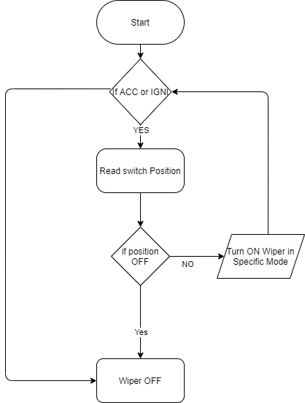

**Fig 4: Flowchart of manual wiper system**

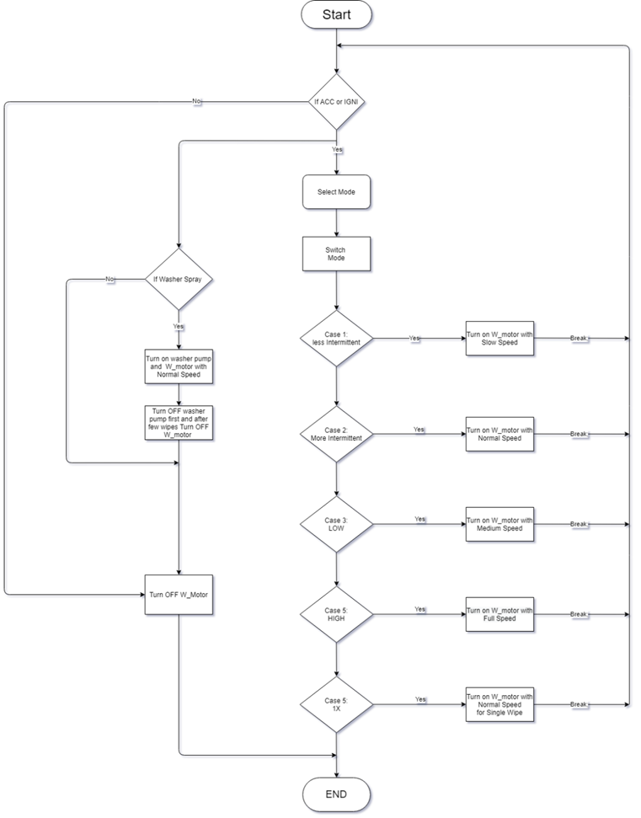

**Fig 5: Algorithm of manual wiper system**

**Safety Blind Zone:**

**Algorithm:**

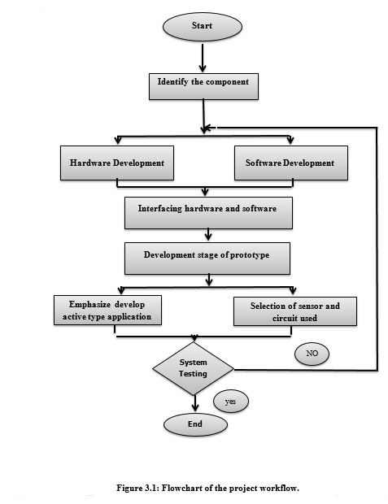

**Fig 6: Algorithm of working of blind spot detection.**

**CRUISE Control:**

**Algorithm:**

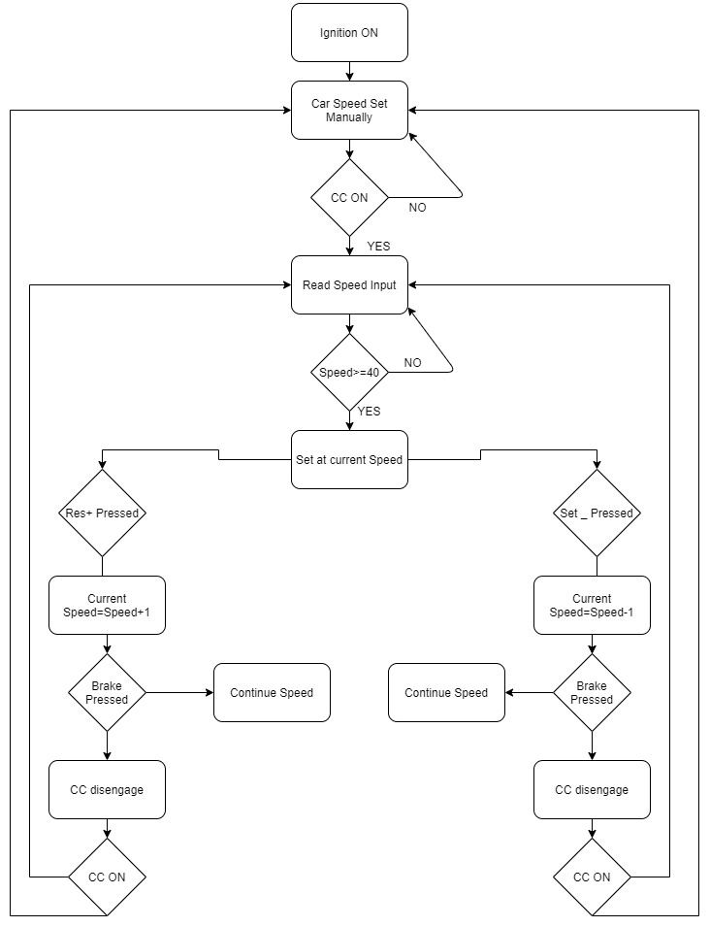

**Fig 7: Algorithm of working of Cruise Control.**

**Air Bag:**

**Algorithm:**

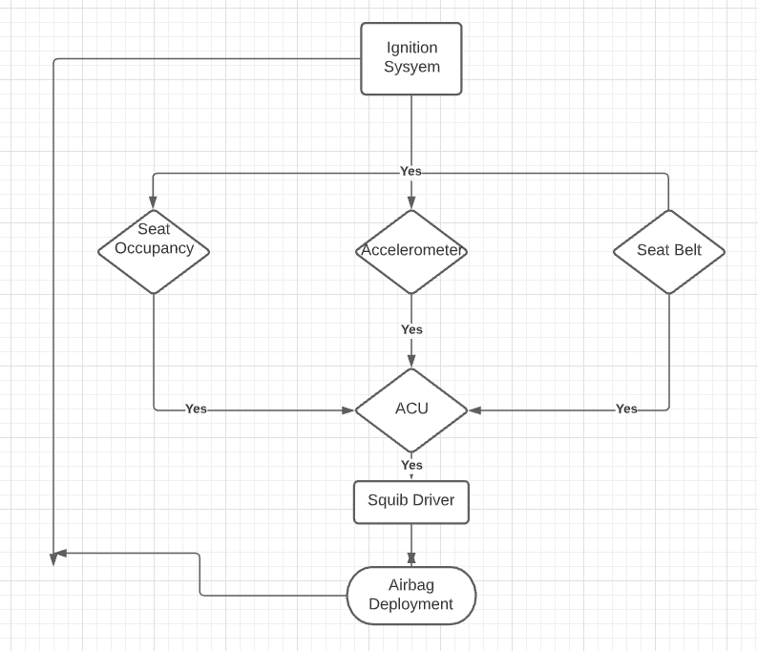

**Fig 8: Algorithm of working of Air Bag system.**

**TPMS:**

**Algorithm:**

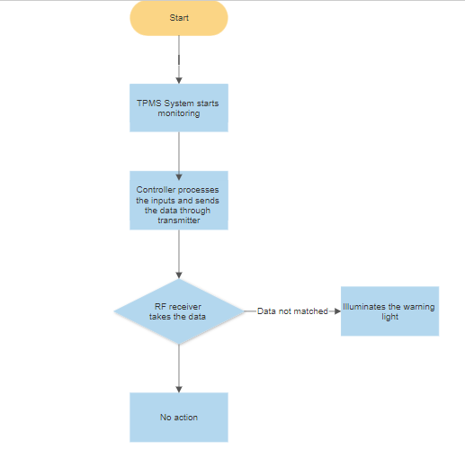

**Fig 9: Algorithm of working of TPMS system.**

**MY FEATURES:**

**WIPER system**

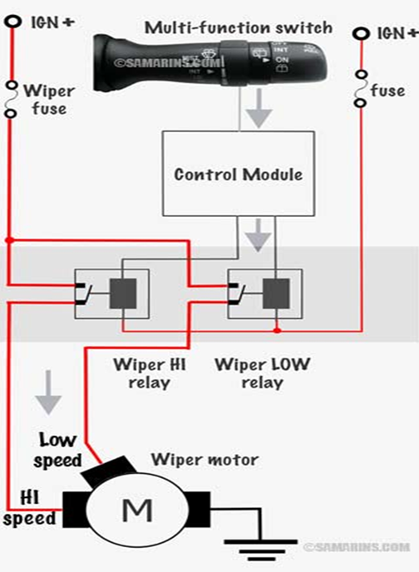

**Figure 10: Model diagram of wiper system**

Basic model of system:

The wipers combine two mechanical technologies to perform their task:

1. A combination **electric motor** and **worm gear** reduction provides power to the wipers.
2. A neat linkage converts the rotational output of the motor into the back-and-forth motion of the wipers.
3. Varying motor speeds:
4. Low speed
5. Medium speed
6. High speed
7. No of swipes: 1X = 1 swipe only, 2X = 2 swipes at a time
8. Washer liquid comes out on the wind screen when the user presses the button.

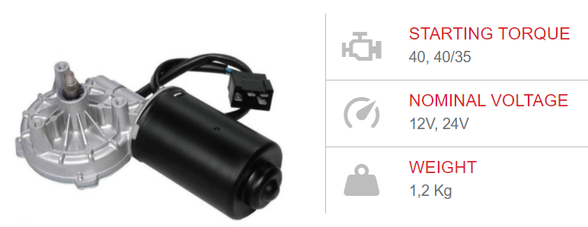

**Figure 11: Gear motor for wiper**

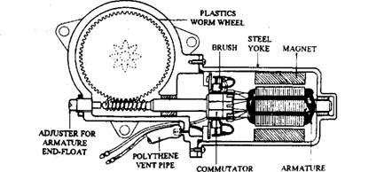

**Figure 12: Permanent Magnet Motor for wiper**

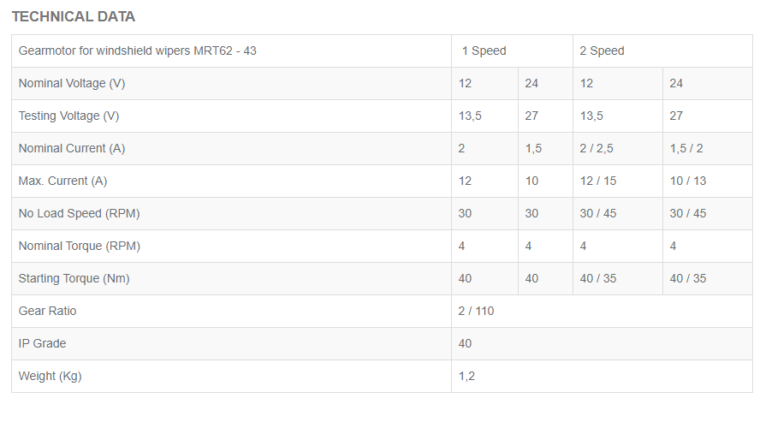

**Figure 13: Datasheet of Gear motor for wiper**

**Comparison table between different motor manufacturers:**

|  |  |  |
| --- | --- | --- |
| SPECIFICATIONS | GEARMOTOR FOR WINDSHIELD WIPERS MRT62-43 | WIPER MOTOR -WD1160 |
| 1. Nominal voltage(V) | 12 | 12 |
| 1. Rated Current (amps) | 12/15 | 6.3 |
| 1. Nominal torque (Nm) | 4 | 5.2 |
| 1. Rated speed (RPM) | 30/45 | 40 |
| 1. Weight (Kg) |  | 2 |

**Table 1: comparison table for 2 types of motor**

**Relay: 1 FORM C AUTOMOTIVE SILENT RELAY**

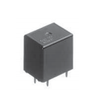

**Figure 14: Automotive Silent Relay**

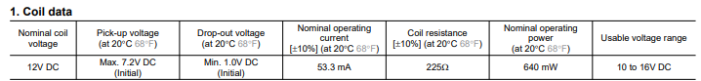

**Table2: Coil data for the relay**

**Push button: Anti-vandal pushbutton switches:**

* Operating temperature: -55 to 85
* LED Rating: 12 AC/DC @ 15mA
* Initial Resistance: <= 10mA
* Contact Rating 10.1A Resistive @ 12VDC

**Links for datasheets:**

1. Wiper motor: WM.pdf
2. Relay: relay wiper.pdf
3. Push Button: [Switch_Catalog.pdf (carlingtech.com)](https://www.carlingtech.com/sites/default/files/documents/Switch_Catalog.pdf)

**MY FEATURES:**

**Cruise Control**

It means your right foot doesn’t need to be pressed down on the accelerator during long trips - and allows you to rid yourself of the temptation to speed - assuming you set it at the speed limit. You still need to use the brake pedal and steer though; this is not a license to fall asleep. Typically, the controls required to operate it are grouped on one of the car’s indicator stalks or on the steering wheel. To switch it on, you will often press a button marked with the symbol for cruise control: a speedometer symbol with an arrow pointing to a set speed.

The most common way to operate cruise control is by using the following buttons:

* **Set** Push this to activate the system. It will hold the speed the car is doing.
* **Cancel** Not the off switch but a button that just pauses the system, if you get stuck behind a slower car, for example. Touching the brake pedal does the same thing.
* **Up** and **Down** (also **+** and **-**) These adjust the cruise control’s set speed. If you are on a motorway and approach a set of roadworkses with a lower speed limit, you can press the minus button reduce the set speed, for example.

You can always override cruise control by using the vehicle’s pedals: pressing the brake will instantly pause the system and slow the car. Pressing the accelerator will increase the car’s speed. When you take your foot off the pedal, the cruise control will usually remain on and return the car to its set speed.

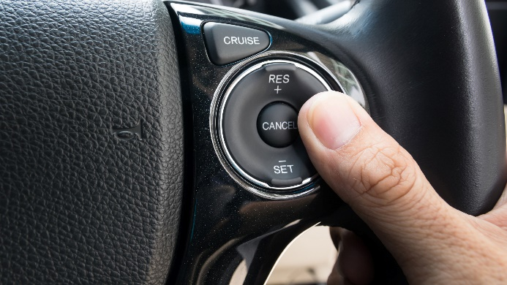

**Fig14: Controlling Cruise Control**

**Components:**

* Throttle Position Sensor
* Toggle Button: rounded rocker Switches
* Push Button
* VDO electronic Speedometer

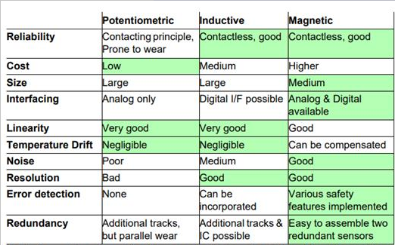

**Table 3: Throttle Sensor Comparison**

**Throttle Position Sensor Parameters:**

|  |  |  |  |  |
| --- | --- | --- | --- | --- |
| S. No. | Parameter | Potentiometric (PC-PTN) | Inductive(LX3302) | Magnetic (TLE4998P) |
| 1. | Supply Voltage | 0 to 10 V DC | 4.0V to 11.0 V | 4.5-5.5 V |
| 2. | Operating temperature | -30 to +100 °C | 40°C to 150°C | -40 to 125 °C |
| 3. | Current | 4-20mA | 6-15 mA | 0 to 5 mA |
| 4. | Frequency/operating Speed | 5 m/s | 8.0 to 8.4 MHz | 122 to 1953 Hz |
| 5. | Resistance | 5K-Ohm ±10% tolerance | 500 K-ohm | 1 K-ohm |

**Table 4: Throttle Sensor parameters**

**Data Sheet Links:**

1. **Potentiometric (PC-PTN)-** [Datasheet_PC_PTN.cdr (position-control.de)](https://www.position-control.de/wp-content/uploads/2016/09/Datasheet_PC_PTN.pdf)
2. **Inductive (LX3302)-** <https://bit.ly/3vIV7zg>
3. **Magnetic (TLE4998P)-** [_TLE4998_Data_Sheet.book (infineon.com)](https://www.infineon.com/dgdl/Infineon-TLE4998P-DataSheet-v01_00-en.pdf?fileId=db3a30431ce5fb52011d3e9a9f3425b1)

**Anti-vandal pushbutton switches:**

* Operating temperature: -55 to 85
* LED Rating: 12 AC/DC @ 15mA
* Initial Resistance: <= 10mA
* Contact Rating 10.1A Resistive @ 12VDC.

**State Transition Diagram:**

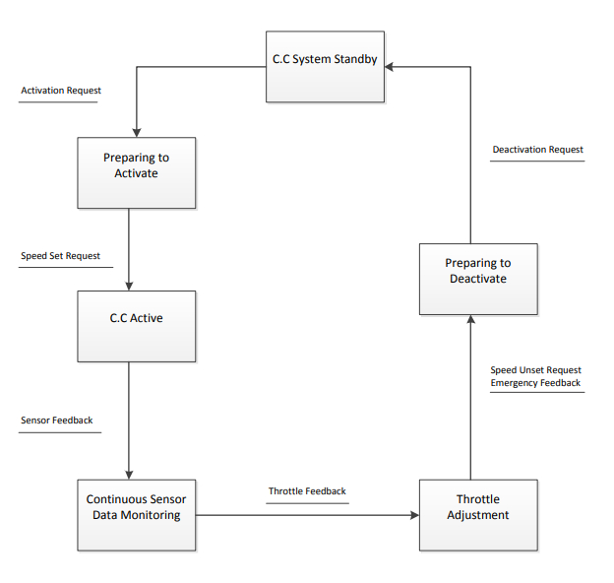

**Fig 15: Cruise Control state Transition diagram**

**System Architecture:**

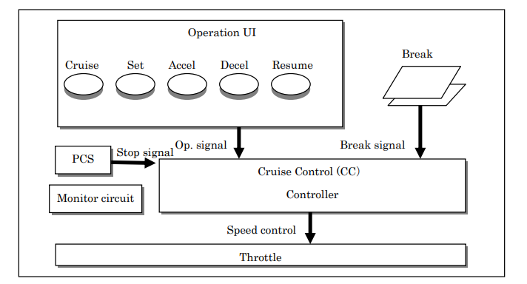

**Fig 16: Cruise Control system architecture**

**Output Parameters:**

VDO ELECTRONIC SPEEDOMETER 1323:

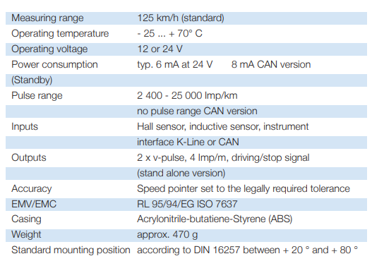

**Table 5: Electronic Speedometer Parameters**

**Dimension and circuit:**

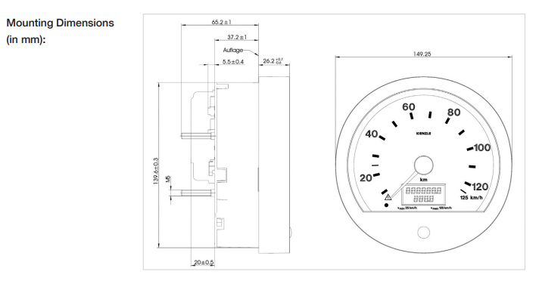

**Fig 17: Cruise Control dimensions**

[**Reference for the data Sheet Link**: https://bit.ly/38RsmXB]

**MY FEATURES:**

**Safety Blind Zone**

A blind spot in a vehicle is an area around the vehicle that cannot be directly observed by the driver while at the controls, under existing circumstances. Blind spots exist in a wide range of vehicles: aircraft, cars, motorboats, sailboats, and trucks. Other types of transport have no blind spots at all, such as [bicycles](https://en.wikipedia.org/wiki/Bicycles), [horses](https://en.wikipedia.org/wiki/Horses), and [motorcycles](https://en.wikipedia.org/wiki/Motorcycles). Proper adjustment of mirrors and use of other technical solutions can eliminate or alleviate vehicle blind spots.

**Input (in car):**

1) For activating the system:

Button (switch)

2) For the Safety blind zone: Radar sensor

**Working:**

Blind Spot Detection is the feature which provide assistance to the driver it sends the radiation and analyze the reflected back signal on the basis of this signal it analyzes the blind spot.

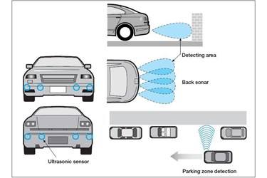

**Fig 18: Working of Blind spot detection.**

**Sensor:**

**QT50R-AFH Sensor (Radar Sensor):**

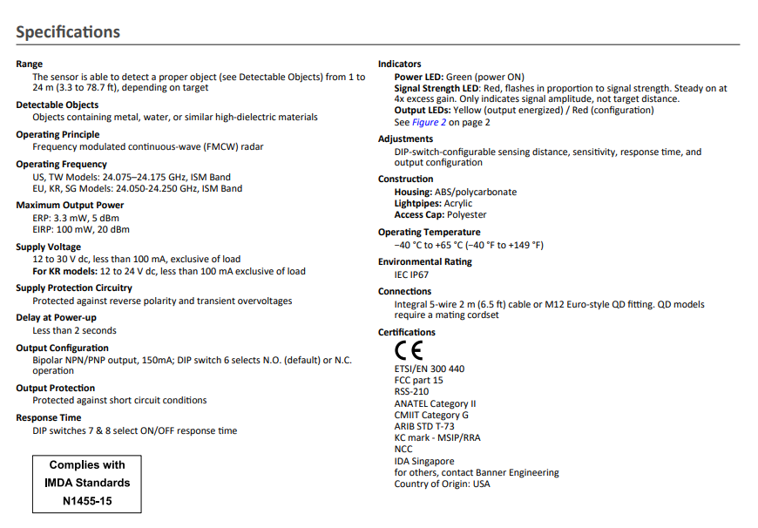

**Fig 19: QT50R Specification Table**

**Sensor:**

**S240RA-IL (-UL) Sensor:**

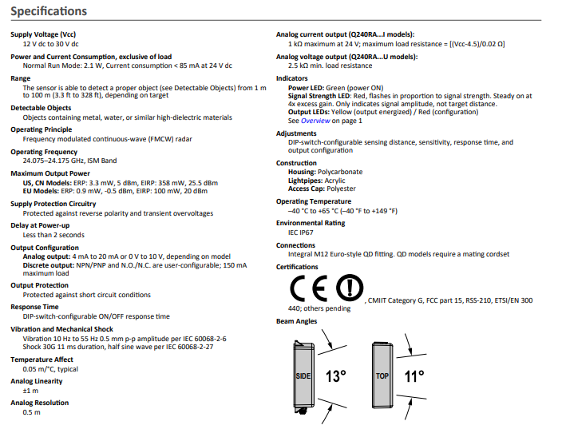

**Fig 20: S240RA Specification Table**

**Hella 77Ghz Radar Sensor:**

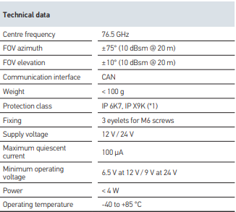

**Table 6: Hella77ghz Specification Table**

**Sensor Comparison:**

|  |  |  |  |
| --- | --- | --- | --- |
| Features | QT50RAFH | Q240RA | Hella 77Ghz |
| Minimum Range | 1m | 1m | 1m |
| Maximum Range | 124ms | 100m | 150m |
| Operating Frequency | 24Ghz | 24Ghz | 76.5Ghz |
| Operating temperature | -40 - (65) degree | -40 – (65) degree | -40 – (85) degree |
| Supply Voltage | 12V-30V | 12V-30V | 12V-24V |
| Operating principle | FMCW | FMCW | FMCW |

**Table 7: Sensor Comparison**

**Output:**

The sensor will provide input to the MCU module and the MCU will activate the hazard light and activate the buzzer sound.

**Features:**

Agglomeration of the entire component to provide lane assist and change of lane assist while driving.

**MY FEATURES:**

**Air Bag**

**Working of Accelerometer Sensor**

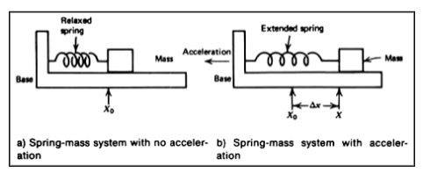

**Fig 21: Working of the Accelerometer Sensor**

An accelerometer is a device that measures the vibration, or acceleration of motion of a structure. The force caused by vibration or a change in motion (acceleration) causes the mass to "squeeze" the piezoelectric material which produces an electrical charge that is proportional to the force exerted upon it. Since the charge is proportional to the force, and the mass is a constant, then the charge is also proportional to the acceleration.

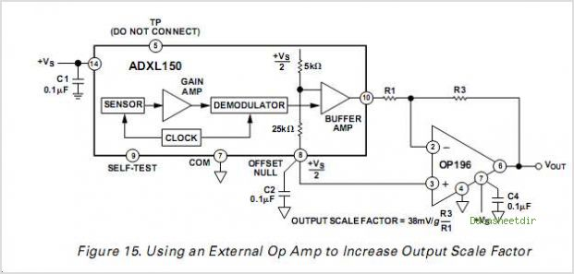

**Fig 22: Op amp to increase the output scale factor.**

[Reference:<https://wiki.metropolia.fi/download/attachments/103256616/Selection_001.png?version=1&modificationDate=1395261133000&api=v2>]

**DATASHEET SPECIFICATIONS**: Accelerometer Sensor

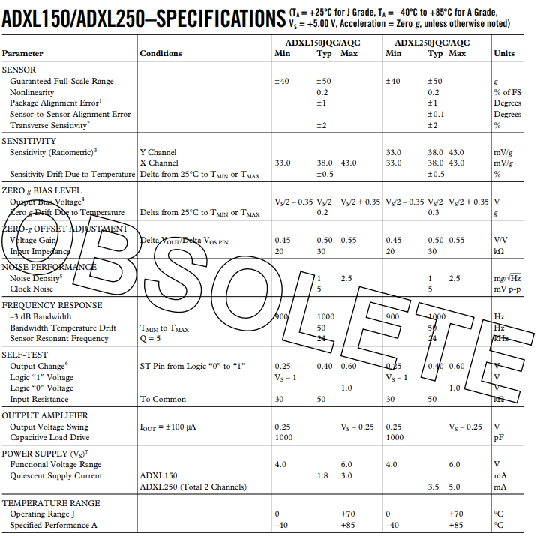

**Fig 23: Datasheet of Accelerometer Sensor**

[Reference:<http://circuits.datasheetdir.com/335/ADXL150-circuits.jpg> ]

The **Seat Occupancy sensor** is a magnetically operated push button **sensor** with a simple push-fit clip mounting configuration, allowing the **passenger** safety system to determine the presence of an object or person in a **seat**.

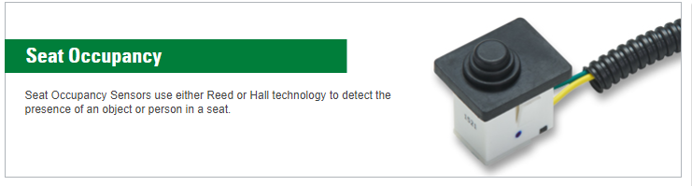

**Fig 24: Seat Occupancy sensor**

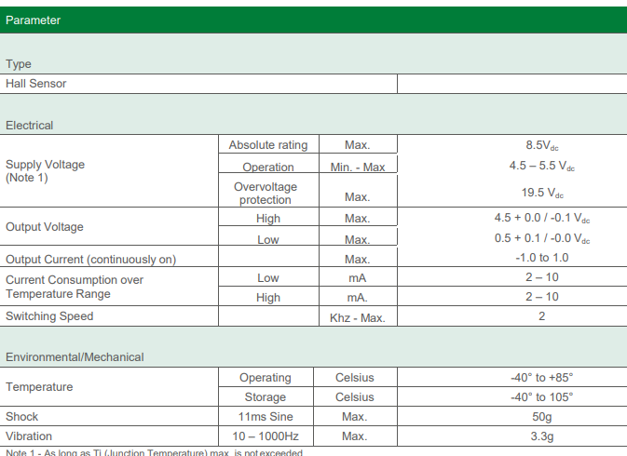

**Fig 25: Seat Occupancy sensor** **datashee**t

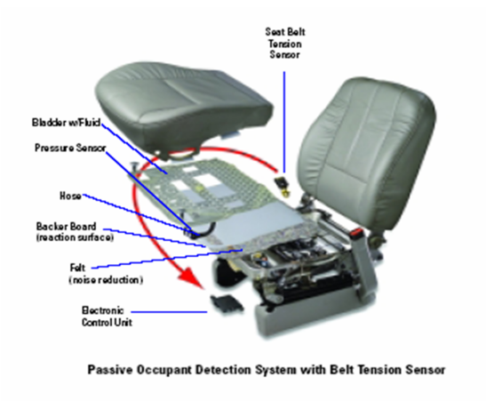

**Fig 26: Seat Occupancy sensor and seat belt tension senor**

**MY FEATURES:**

**TPMS**

**Input**: Pressure Sensor: AMS5915

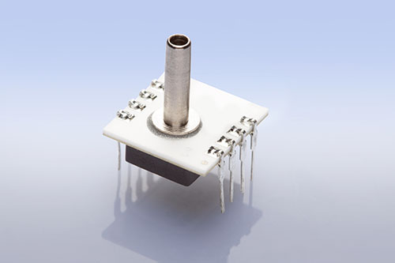

**Fig 27: Pressure Sensor: AMS5915**

**Fig 28: Pressure Sensor AMS5915 overview**

Overview:

Characteristics:

* Supply voltage:3.3V.
* Pressure range:0-58.02psi.
* Operating temperature: -25C to 85C
* ADC:14 bit.
* Output: I2C ports.

**Calculations:**

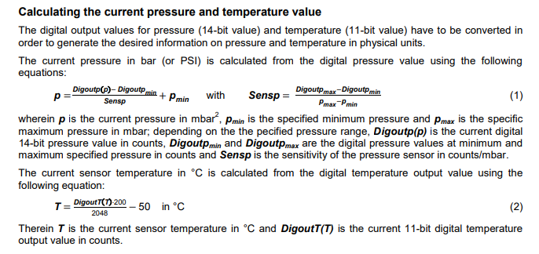

**Fig 29: Calculations of the current and pressure**

**Features:**

* Monitors pressure on all the 4 wheels.
* AMS5915 integrated sensor used.
* Uses RF transmitter and receiver to send and collect the data.
* If the sensor value Is lesser than the threshold value, the warning light of TPMS illuminates and alerts the driver.

# SWOT ANALYSIS:

|  |  |
| --- | --- |
| **STRENGTHS**  **Manual Wiper System**   * multi utility * user friendly * compact design * sturdy * 2-speed   **Safety Blind Zone**   * Long Range Sensor * DIP Switch Configurable   **Cruise Control**   * Increases Safety and comfort * Smoothens traffic flow * Decrease fuel consumption * Decreases Environmental pollution * Driver effort reduces   **Air Bag**   * Increasing cushioning around his neck, head, and spine. * Decreasing the amount of force impacting a person's head by limiting the distance it can fling forward. * Decreasing the risk that a victim will project through the window or be ejected from the car.   **Tire Pressure**   * Accurately measures the pressure of all the 4 tires. * Avoids miss happenings like tire burst. | **WEAKNESS**  **Manual Wiper System**   * Does not support automated wiping system. * Not an intelligent system   **Safety Blind Zone**   * Expensive system * Margin of error is less   **Cruise Control**   * Limited Speed range operations * Control laws that do not ensure traffic stability under all circumstances * Can’t be used in traffic   **Air Bag**   * Cost * Inflation force. * Deployment ignition   **Tire Pressure**   * Expensive compared to competitors. * 0.1% probability of wrong readings. |
| **OPPORTUNITIES**  **Manual Wiper System**   * It can be converted to automatic wiper system integrated with rain sensor.   **Safety Blind Zone**   * In future lower variant car can also have blind spot detection feature * Use of image processing in implementing the same scenario   **Cruise Control**   * Technology maturity may reduce system chart * Technology will make vehicles autonomous   **Air Bag**   * Four wheelers like cars, trucks   **Tire Pressure**   * Advanced compared to other models in the market. * Helps reducing accidents which are fatal. | **THREATS**  **Manual Wiper System**   * Leakage from the washer * Pump malfunction * Motor failure * Wiper failure due to excessive dust, snow   **Safety Blind Zone**   * Image processing might take the market * Weather can affect the sensor value   **Cruise Control**   * User acceptance in terms of both purchase intention and frequent activation after purchase * May cause drowsiness to driver   **Air Bag**   * Competition from products of higher features.   **Tire Pressure**   * New entry into the market, less reputation. * More competitors. |

**Table 8: SWOT Analysis**

# DESIGN: DETAILED REQUIREMENTS

## **High Level Requirements**

|  |  |
| --- | --- |
| High Level Requirement ID | Description |
| H1_SBZ | Processing of all the sensor data |
| H2_SBZ | Response should be accurate and fast |
| H3_W | Handle Knob for Wiper speed and swipes |
| H4_W | Push button for water jet spray |
| HL1_Cc | Cruise Control Button |
| HL2_Cc | Set Button |
| HL3_Cc | Cancel Button |
| HL4_Cc | **+ve** Button |
| HL5_Cc | **-ve** Button |
| HL6_Cc | Speedometer |
| HL7_AB_1 | Airbag must deploy under medium and hard crashes. |
| HL8_TP_01 | To sense the required pressure. |
| HL9_TP_02 | To be stable at varying temperature. |
| HL10_TP_03 | Alert the driver if pressure is not correct. |

## **Low Level Requirement:**

|  |  |
| --- | --- |
| Low Level Requirement ID | Description |
| L1_SBZ | Sensor should be accurate. |
| L2_SBZ | EPU process all the Data at a single time |
| L3_W | Wiper motor: Gear motor for windshield wipers MRT62-4 |
| LL1_Cc | On pressing Cruise Control Button: The feature will get on and check for the conditions required for cruise control |
| LL2_Cc | On pressing the Set button: The speed of the Vehicle will get set to the current speed |
| LL3_Cc | On pressing the Cancel button: The cruise control feature will disengage |
| LL4_Cc | On pressing the +ve button: The speed of the vehicle will get added by 1 |
| LL5_Cc | On pressing the -ve button: The speed of the vehicle will get subtracted by 1 |
| LL6_Cc | The output speed will be displayed to speedometer |
| LL7_AB | Accelerometer must sense the sudden deceleration during crash and give input to the controller accordingly. |
| LL8_AB | Seat occupancy pressure sensor detects the person sitting on the seat and sends input to the controller. |
| LL9_AB | Seat belt sensor gives input to the controller whether it is equipped or not. |
| LL10_AB | These sensors signals should trigger the Squib system which is the circuit that ignites the airbag deployment unit. |
| LL11_TP_01 | Placement of sensors. |
| LL12_TP_02 | To check in all terrains. |

# TEST CASES:

## **HIGH Level Test Plan:**

|  |  |  |  |  |  |  |
| --- | --- | --- | --- | --- | --- | --- |
| TEST ID | DESCRIPTION | EXPECTED INPUT | ACTUAL  INPUT | EXPECTED  OUTPUT | ACTUAL  OUTPUT | TYPE OF TEST |
| H_01_IGON | Ignition | Ignition button pressed | Button pressed | Engine turned on | Engine turned on | Senerio based |
| H_02_WBON | Wiper button | Ignition button pressed | Button pressed | Wiper mode turs on to vary wiper speeds | Wiper mode turs on to vary wiper speeds | Senerio  Based |
| HL_SBZ_1 | Engine is off | Ignition=off | Ignition=off | Lamp = off | Lamp = off | Boundary condition |
| HL_SBZ_2 | Engine is on, left sensor and right sensor both detect no input | Ignition=on | Ignition=on | Lamp=off | Lamp = off | In Range |
| HL_SBZ_3 | Engine is on, both sensors detect input | Ignition = on, And the object is behind the car | Ignition = on, And the object is behind the car | Lamp = on | Lamp= on | In Range |
| HL_SBZ_4 | Engine is on, left sensor and right sensor both detect no input | Ignition = Off, And the object is behind the car | Ignition = Off, And the object is behind the car | Lamp = off | Lamp = off | Out of bound |
| HL_CC1 | Cruise Control Button | Button Pressed | Button pressed | Button Got ON when pressed, Got OFF when again Pressed | Button Got ON when pressed, Got OFF when again Pressed | Requirement |
| HL_CC2 | Set Button | Button Pressed | Button pressed | Button Got ON when pressed, Got OFF when again Pressed | Button Got ON when pressed, Got OFF when again Pressed | Requirement |
| HL_CC3 | Cancel Button | Button Pressed | Button pressed | Button Got ON when pressed, Got OFF when again Pressed | Button Got ON when pressed, Got OFF when again Pressed | Requirement |
| HL_CC4 | +ve Button | Button Pressed | Button pressed | Button got ON for the time button is Pressed, else OFF | Button got ON for the time button is Pressed, else OFF | Requirement |
| HL_CC5 | -ve Button | Button Pressed | Button pressed | Button got ON for the time button is Pressed, else OFF | Button got ON for the time button is Pressed, else OFF | Requirement |
| HL_CC6 | Speedometer | Speed reflected | Speed reflected | Speed of the vehicle | Speed of the vehicle | Requirement |
| TP_01 | Check Tire with no air | 0 | 0 | Warning light illumination | Warning light illumination | Boundary condition |
| TP_02 | Inflate with 5 psi. | 5 | 5 | Warning light illumination | Warning light illumination | In Range |
| TP_03 | Inflate with 32 psi. | 32 | 32 | No Warning light | No  Warning light | In Range |
| TP_04 | Inflate with 34 psi. | 34 | 34 | No Warning light | No Warning light | Boundary condition |
| TP_05 | Inflate with 45 psi. | 45 | 45 | Warning light illumination | Warning light illumination | Out of bound |
| HL_01_Airbag | Crash Detection | Speed difference  >40kmph | Voltage input | Airbag deployed | Airbag Deployed | Scenario based |

## **Low Level Test Plan:**

|  |  |  |  |  |  |  |
| --- | --- | --- | --- | --- | --- | --- |
| TEST ID | DESCRIPTION | EXPECTED INPUT | ACTUAL INPUT | EXPECTED  OUTPUT | ACTUAL  OUTPUT | TYPE OF TEST |
| L_01_LS | Wiper in low speed mode | Input to the wiper motor | Input to the wiper motor | Wiper working properly | Wipes in low speed | Behavioural |
| L_02_MS | Wiper in medium speed mode | Input to motor | Input to the wiper motor | Wiper working properly | Voltage increase to the wiper motor Wipes in medium speed | Behavioural |
| L_03_HS | Wiper in high speed mode | Input to motor | Input to the wiper motor | Wiper working properly | Voltage increase to the wiper motor so Wipes in high speed | Behavioral |
| L_04_OS | Wiper in 1X mode | Input to motor | Input to the wiper motor | Wiper working properly | Voltage increase to the wiper motor Wipes once | Behavioral |
| L_05_TS | Wiper in 2X mode | Input to motor | Input to the wiper motor | Wiper working properly | Voltage increase to the wiper motor Wipes twice | Behavioural |
| L_06_OFF | Engine shutdown error | Input to the motor is cut | Input to the wiper motor | Input to the motor is cut | Wiper motor stops resulting in stop of wiper | Scenario based |
| LL_CC1 | Cruise Control button is ON | CC Button Pressed | CC Button pressed | Cruise control feature getting enabled and checking whether it can be implemented in present conditions | Cruise control feature getting enabled and checking whether it can be implemented in present conditions | Behavioural |
| LL_CC2 | Cruise Control button is OFF | CC Button Pressed again | CC Button pressed again | Cruise control feature not getting enabled and not checking whether it can be implemented in present conditions | Cruise control feature not getting enabled and not checking whether it can be implemented in present conditions | Behavioural |
| LL_CC3 | SET button ON | Set button pressed | Set button pressed | Speed of vehicle get set to current speed | Speed of vehicle get set to current speed | Behavioural |
| LL_CC4 | CANCEL Button ON | Cancel button pressed | Cancel button pressed | The cruise control button will disengage | The cruise control button will disengage | Scenario based |
| LL_CC5 | +ve button clicked | +ve button pressed | +ve button Pressed | The speed will increase by 1 | The speed will increase by 1 | Scenario based |
| LL_CC6 | -ve button clicked | -ve button pressed | -ve button pressed | The speed will decrease by 1 | The speed will decrease by 1 | Scenario based |
| LL_CC7 | CC button ON but speed is less than 40 | Speed less than 40, CC button pressed | Speed less than 40, CC button pressed | The CC will not get engage | The CC will not get engage | Scenario based |
| LL_SBZ_1 | The object is 0.5m behind the car. | Sensor = 0.5m | Sensor = 0.5m | Lamp = on | Lamp = off | Out of bound |
| LL_SBZ_2 | The object is 1m behind the sensor | Sensor = 1m | Sensor = 1m | Lamp = on | Lamp = on | In Range |
| LL_SBZ_3 | The Object is 149m behind | Sensor = 149m | Sensor = 149m | Lamp = on | Lamp = on | In Range |
| LL_SBZ_4 | The object is 160m behind | Sensor = 160m | Sensor = 160m | Lamp = off | Lamp = off | Out of bound |
| TP_06 | Check in Hot weather(35C) | 34 | 34 | No warning | No warning | Boundary condition |
| TP_07 | Check in cold weather(18C) | 32 | 32 | No warning | No warning | In Range |
| TP_08 | Check in std weather(25C) | 32 | 32 | No warning | No warning | In Range |
| LL_01_Airbag | Type of crash detection | Speed diff>40kmph and Yaw rate | Voltage input | Airbag deployed | Airbag deployed | Scenario based |
| LL_03_Airbag | Check for Seat occupancy | Weight>20kg | Voltage input | Airbag deployed | Airbag deployed | Requirement based |
| LL_04_Airbag | No Seat Occupied | Weight<20kg | Voltage input | Airbag deployed | Airbag deployed | Requirement based |
| LL_05_Airbag | Seat belt checking | Seat belt ON  Buckle Switch ON | Voltage input | Tighten the buckle during crash | Tighten the buckle during crash | Requirement based |
| LL_06_Airbag | Seat belt checking | Seat belt OFF  Buckle OFF | Voltage input | No Airbag Deployment | No Airbag Deployment | Requirement based |

# Simulink Model of the BCM Module

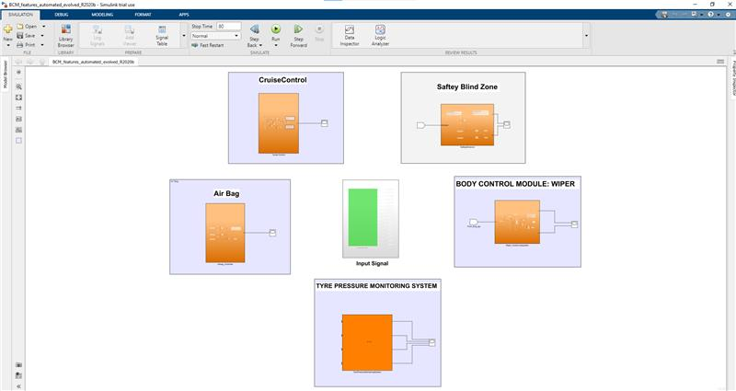

**Fig 30: Automated model of BCM Module**

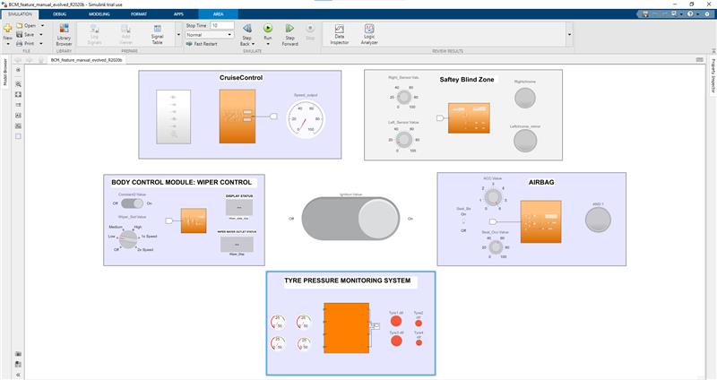

**Fig 31: Manual model of BCM Module**

# COMPLIANCE REPORTS

## **MCDC Coverage report**

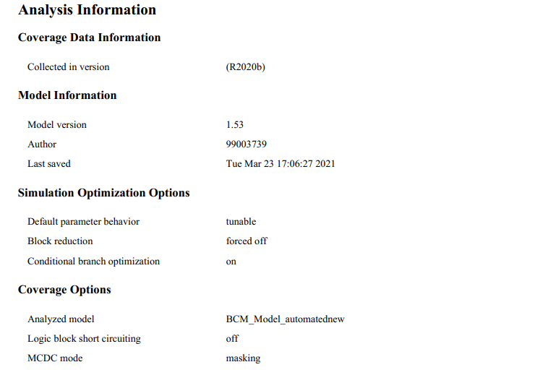

**Fig 32: MCDC coverage analysis information**

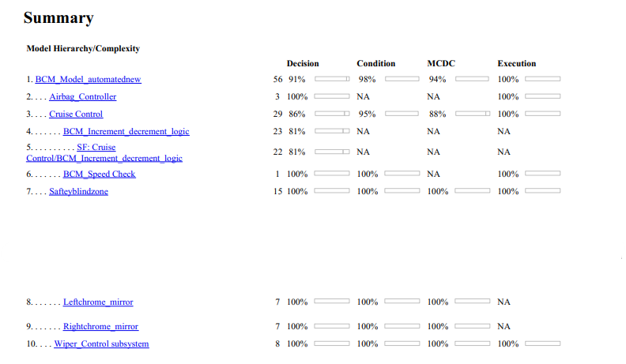

**Fig 33: MCDC coverage report summary**

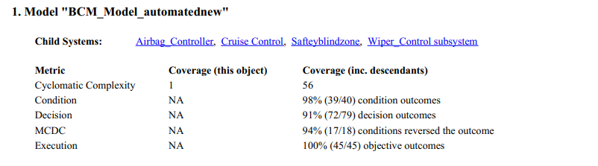

**Fig 34: MCDC coverage report summary of child systems**

## **MODEL ADVISORY REPORT**

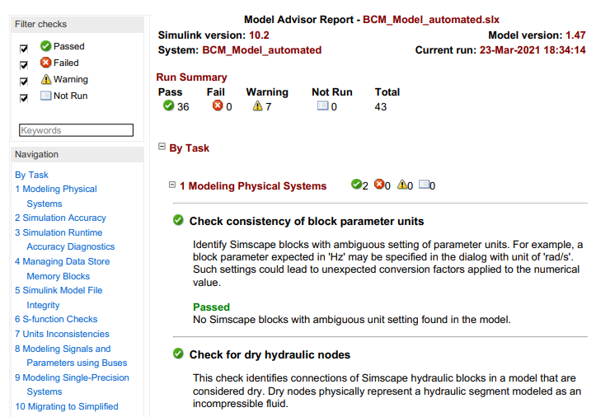

**Fig 35: Model Advisory report**

# MAAB

## **Safety Blind Zone**

**Initial Model**

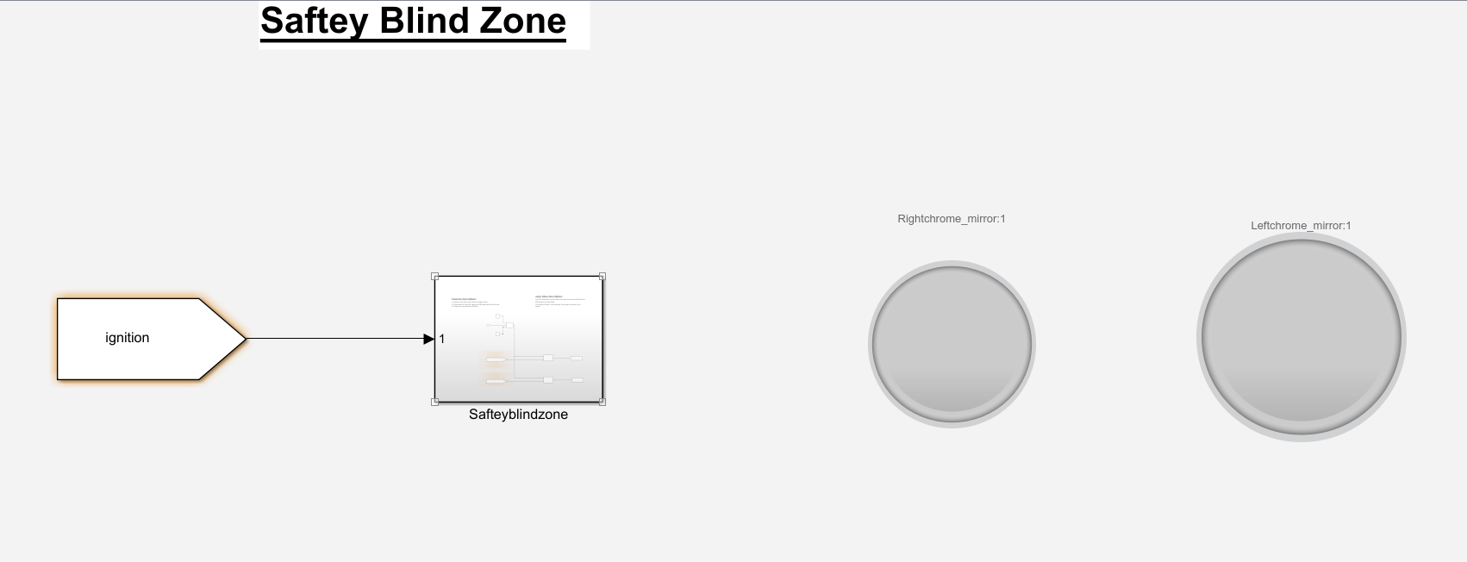

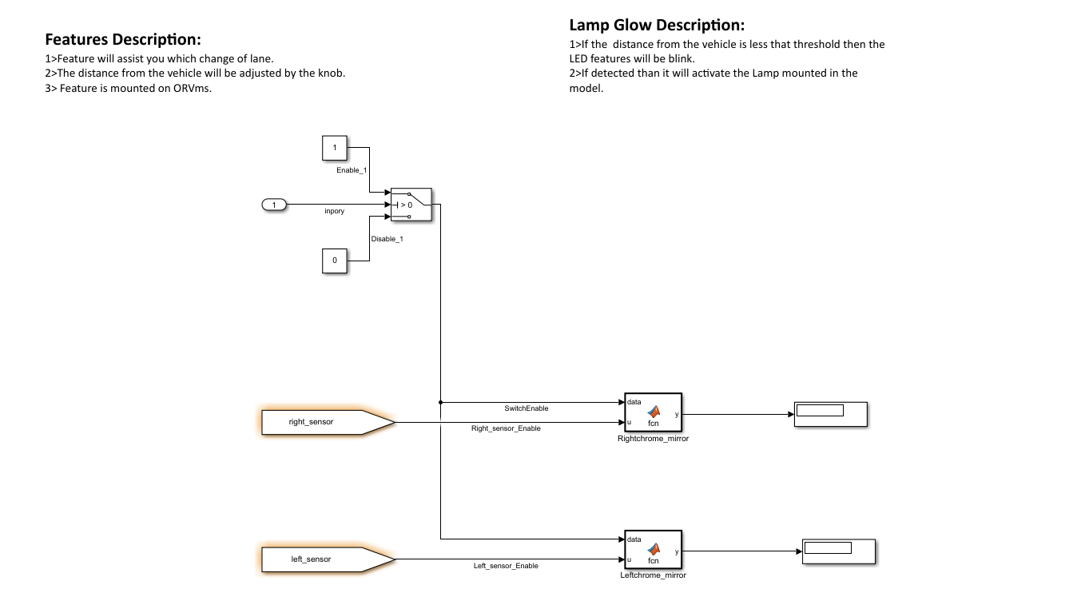

#### MAAB Feature applied

**jc_0231: Usable characters for block names**

Sub ID a:

Only these character types shall be used for basic block names:

Single-byte alphanumeric characters (a-z, A-Z, 0-9)

Single-byte underscore (_)

Line breaks and single-byte spaces shall not be permitted when adding a new block name. However, they shall be permitted when used initially as a block name that is saved in the Simulink® library.

Double-byte characters and control characters shall not be used.

Sub ID b:

Basic block names shall not use numbers at the beginning.

Sub ID c:

Basic block names shall not use underscores at the beginning.

Sub ID d:

Basic block names shall not use underscores at the end.

Sub ID e:

Basic block names shall not use consecutive underscores.

Sub ID f:

Basic block names shall not consist solely of a single reserved MATLAB word.

**jc_0211: Usable characters for in port blocks and Outport block**

Sub ID a

Only these character types shall be used in [in port](https://www.mathworks.com/help/simulink/slref/inport.html) and [Outport](https://www.mathworks.com/help/simulink/slref/outport.html) block names:

Single-byte alphanumeric characters (a-z, A-Z, 0-9)

Single-byte underscore (_)

Line breaks, single-byte spaces, double-byte characters, and control characters shall not be used.

Sub ID b

[in port] and [Outport] block names shall not use numbers at the beginning.

Sub ID c

[in port] and [Outport] block names shall not use underscores at the beginning.

Sub ID d

[in port] and [Outport] block names shall not use underscores at the end.

Sub ID e

[In port] and [Outport] block names shall not use consecutive underscores.

**jc_0243: Length restriction for subsystem names**

Sub ID a

Structural subsystem name length shall be a maximum of 63 characters.

**jc_0247: Length restriction for block names**

Sub ID a

Basic block name length shall be a maximum of 63 characters.

**jc_0244: Length restriction for Inport and Outport names**

Sub ID a

[Inport](https://www.mathworks.com/help/simulink/slref/inport.html) and [Outport](https://www.mathworks.com/help/simulink/slref/outport.html) block name length shall be a maximum of 63 characters.

Output after implementing all the feature

**Final Model**

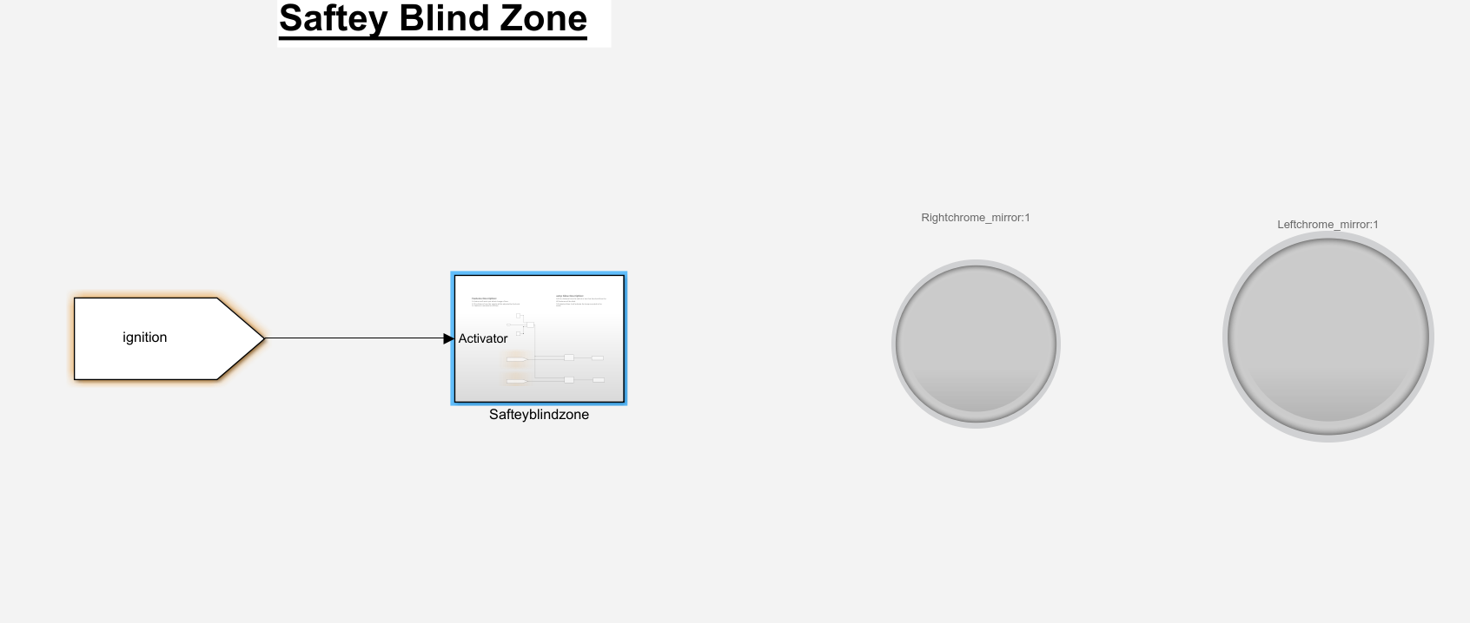

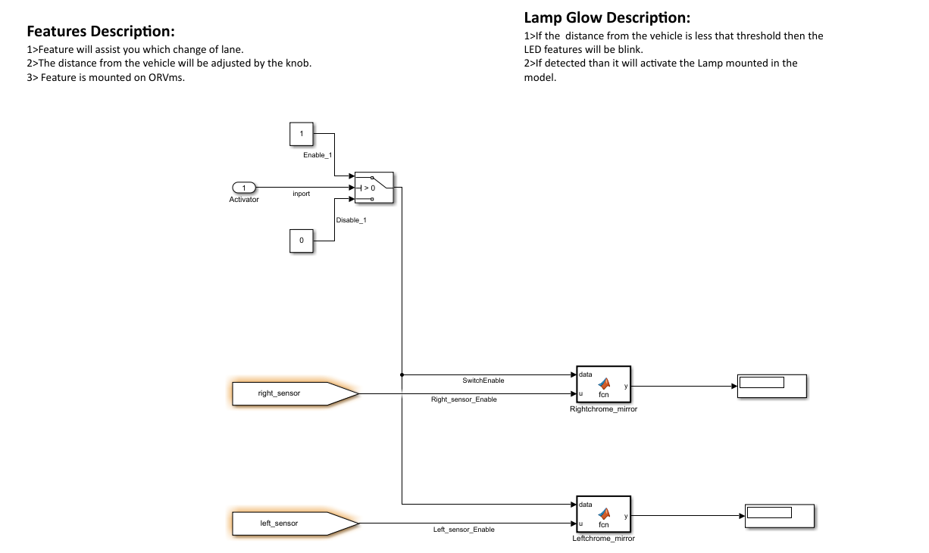

## **Tyre pressure monitoring system**

**Initial model**

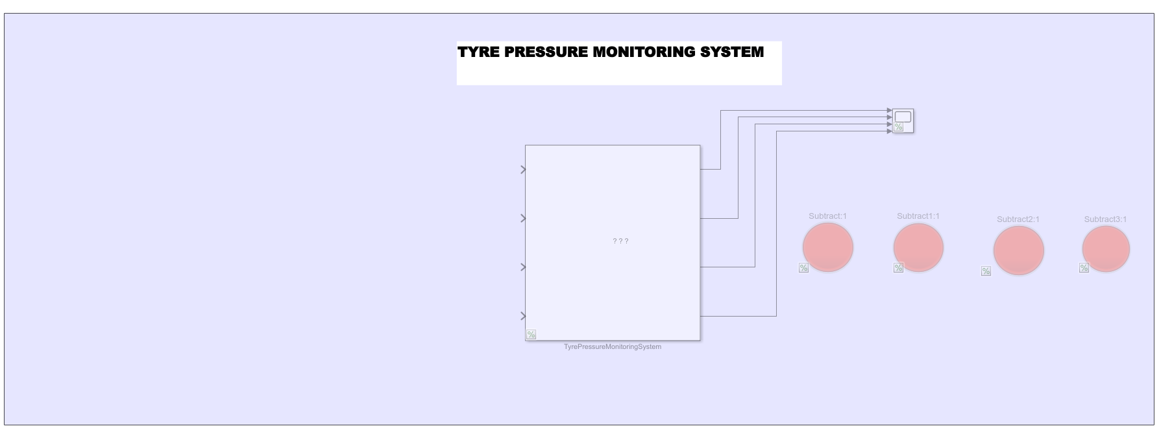

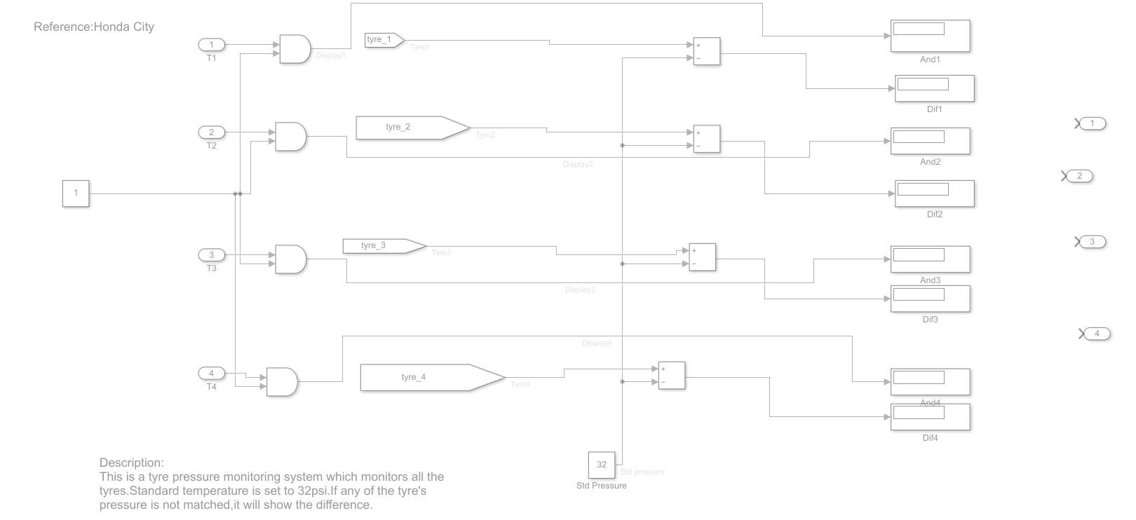

#### **MAAB Feature applied**

### ar_0001: Usable characters for file names

### Sub ID a

Only these character types shall be used in file names:

Single-byte alphanumeric characters (a-z, A-Z, 0-9)

Single-byte underscore (_)

Line breaks, single-byte spaces, double-byte characters, and control characters shall not be used. File types that are checked for model and MATLAB files shall be set in the project settings.

### Sub ID b

The file name shall not use numbers at the beginning.

### Sub ID c

The file name shall not use underscores at the beginning.

### Sub ID d

The file name shall not use an underscore at the end.

### Sub ID e

The file name shall not use consecutive underscores.

### Sub ID f

The file name shall not consist solely of a single reserved MATLAB word.

### Sub ID g

File names on the MATLAB path shall not be identical.

**ar_0002: Usable characters for folder names**

Sub ID a

Only these character types shall be used in folder names:

Single-byte alphanumeric characters (a-z, A-Z, 0-9)

Single-byte underscore (_)

Line breaks, single-byte spaces, double-byte characters, and control characters shall not be used.

Sub ID b

The folder name shall not use numbers at the beginning.

Sub ID cThe folder name shall not use underscores at the beginning.

Sub ID d

The folder name shall not use underscores at the end.

Sub ID e

The folder name shall not use consecutive underscores.

Sub ID f

The folder name shall not consist solely of a single reserved MATLAB® word.

**jc_0241: Length restriction for model file names**

Sub ID a

Model file name length shall be a maximum of 63 characters (not including dots and extension).

**jc_0201: Usable characters for subsystem names**

Sub ID a

Only these character types shall be used in structural subsystem names:

Single-byte alphanumeric characters (a-z, A-Z, 0-9)

Single-byte underscore (_)

Line breaks, single-byte spaces, double-byte characters, and control characters shall not be used.

Sub ID b

A structural subsystem name shall not use numbers at the beginning.

Sub ID c

A structural subsystem name shall not use an underscore at the beginning.

Sub ID d

A structural subsystem name shall not use an underscore at the end.

Sub ID e

A structural subsystem name shall not use consecutive underscores.

Sub ID fA structural subsystem shall not consist solely of a single reserved MATLAB® word.

**jc_0242: Length restriction for folder names**

Sub ID a

Folder name length shall be a maximum of 63 characters.

**Output Model**

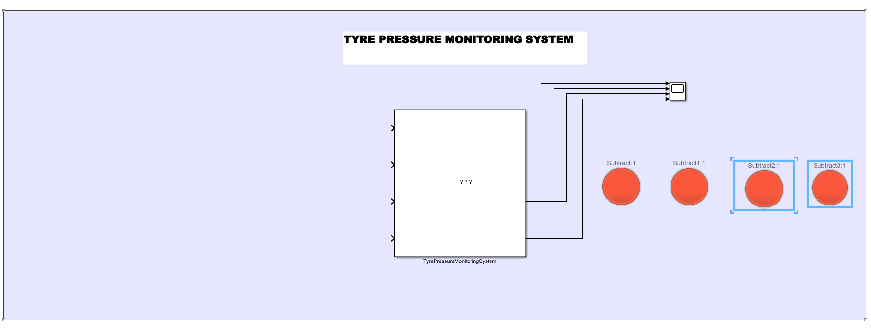

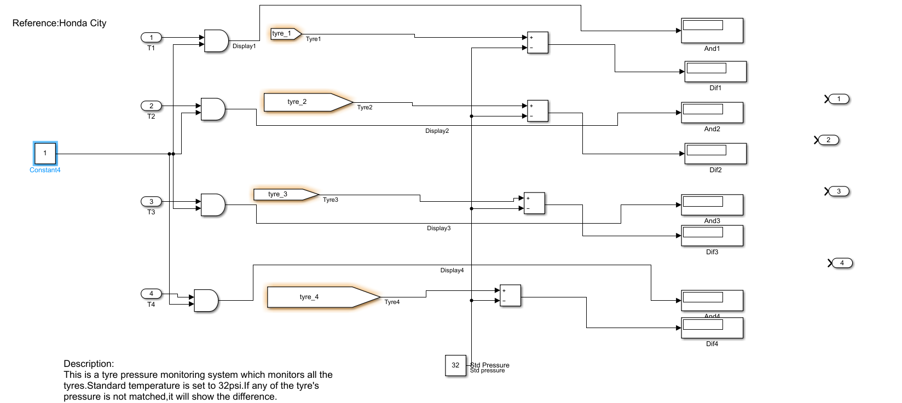

#### MAAB Feature applied

## **Wiper System**

**Initial Model**

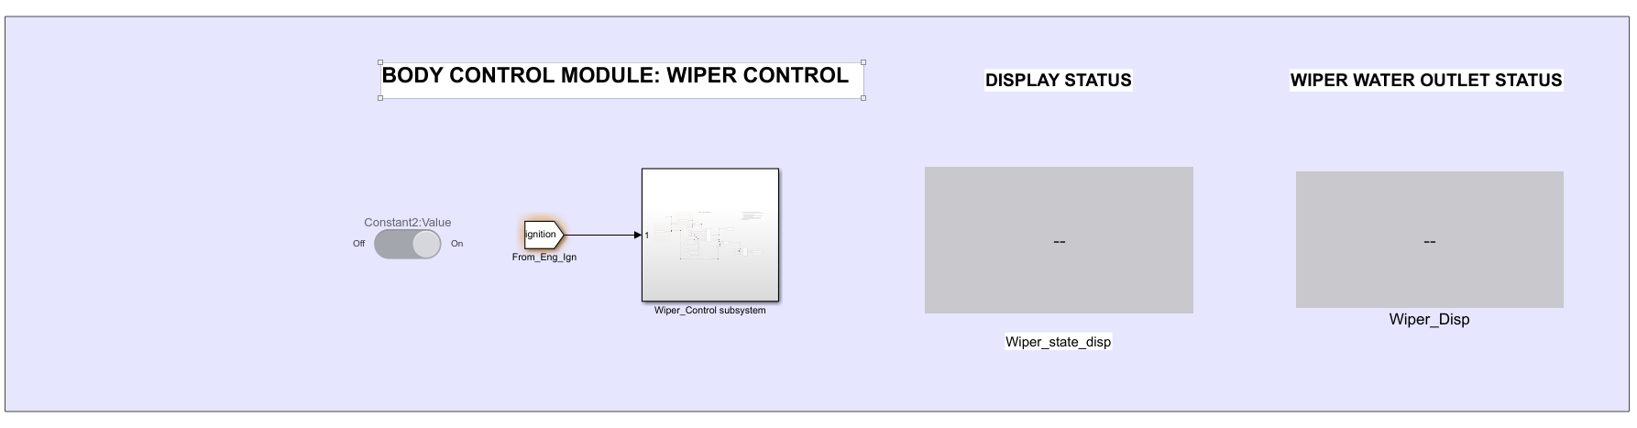

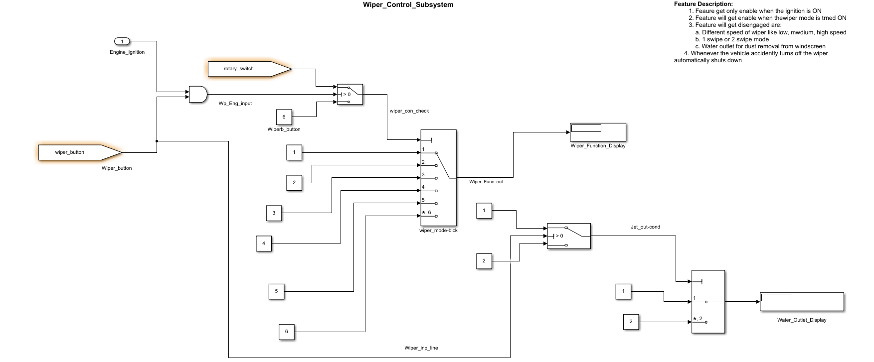

**jc_0222: Usable characters for signal and bus names**

Sub ID a

Only these character types shall be used in signal and bus names:

Single-byte alphanumeric characters (a-z, A-Z, 0-9)

Single-byte underscore (_)

Line breaks, single-byte spaces, double-byte characters, and control characters shall not be used.

Sub ID b

Signal and bus names shall not use numbers at the beginning.

Sub ID c

The signal or bus name shall not use underscores at the beginning.

Sub ID d

Signal and bus names shall not use underscores at the end.

Sub ID e

Signal and bus names shall not use consecutive underscores.

Sub ID f

Signal and bus names shall not consist solely of a single reserved MATLAB® word.

**jc_0232: Usable characters for parameter names**

Sub ID a

Only these character types shall be used in parameter names:

Single-byte alphanumeric characters (a-z, A-Z, 0-9)

Single-byte underscore (_)

Line break, single-byte space, double-byte characters, and control characters shall not be used.

Sub ID b

The parameter name shall not use numbers at the beginning.

Sub ID c

The parameter name shall not use underscores at the beginning.

Sub ID d

The parameter name shall not use underscores at the end.

Sub ID e

The parameter name shall not use consecutive underscores.

Sub ID f

The parameter name shall not consist solely of a single reserved MATLAB word.

**jc_0245: Length restriction for signal and bus names**

Sub ID a

Signal and bus name length shall be a maximum of 63 characters.

**jc_0246: Length restriction for parameter name**

Sub ID a

Parameter name length shall be a maximum of 63 characters.

**jc_0795: Usable characters for State flow data names**

Sub ID a

State flow data {name} shall not use underscores at the beginning.

Sub ID b

State flow data {name} shall not use underscores at the end.

Sub ID c

State flow data {name} shall not use consecutive underscores.

Sub ID d

State flow data {name} shall not consist solely of a single reserved MATLAB word.

**Output Model**



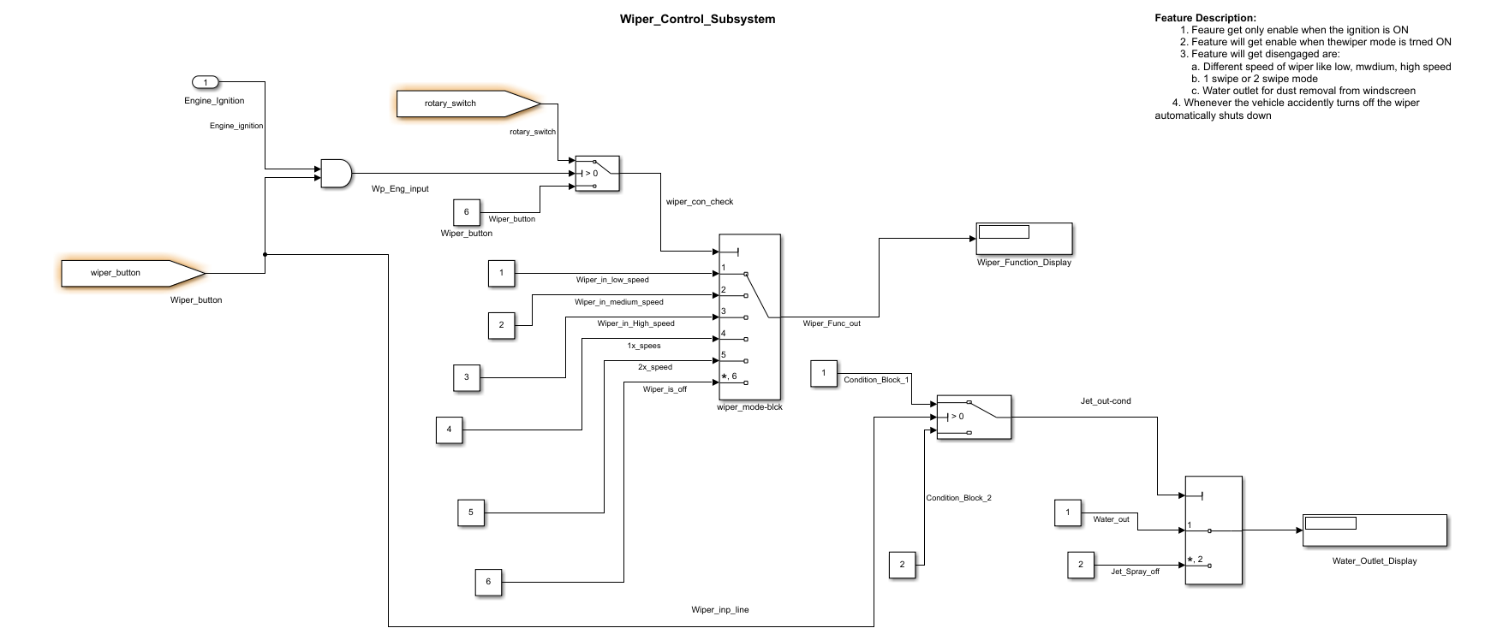

## **AIRBAG**

**Input model**

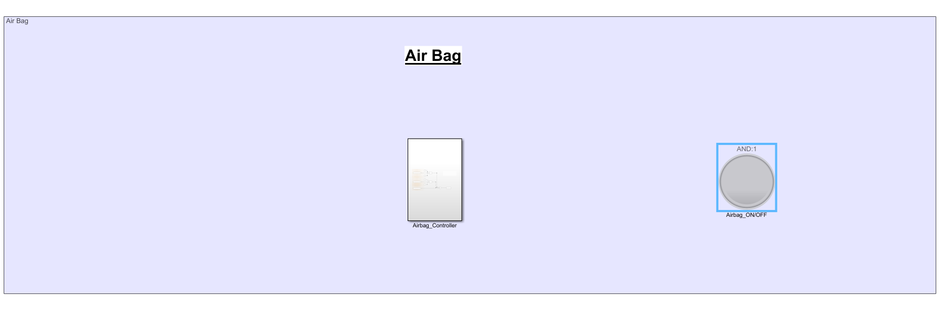

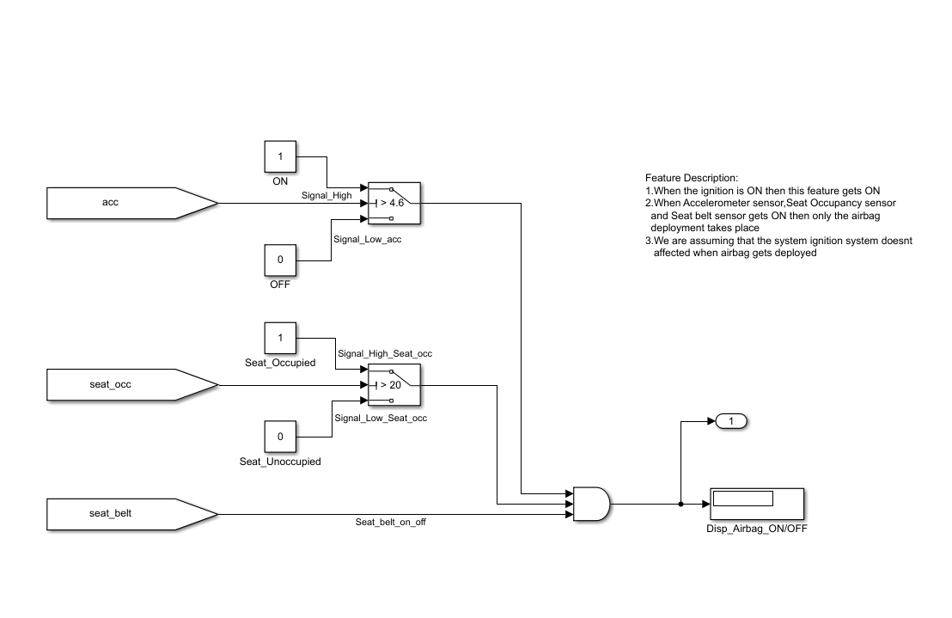

**na_0004: Simulink model appearance settings**

Sub ID a

Simulink® model appearance settings shall conform with the project settings.

**db_0043: Model font and font size**

Sub ID a

Block name font and font style shall conform with the project settings.

Signal name font and font style shall conform with the project settings.

Sub ID b

State labels and box name font and font style shall conform with the project settings.

Transition labels and comment font and font style shall conform with the project settings.

**jm_0002: Block resizing**

Sub ID a

Blocks shall be sized so that the block icon is visible and recognizable.

**jc_0061: Display of block names**

Sub ID a

Block names shall be hidden for blocks that meet the following criteria:

Block type is evident from its visual appearance

Uses the default block name (including instances where only a number has been added at the end)

For blocks that do not meet the criteria, their name shall be displayed.

**jc_0603: Model description**

Sub ID a

The model layer shall include a description of the layer.

Layers that require a description are defined (by function and layer type) in the project.

Sub ID b

The format of the layer description shall be consistent in the model.

**Output Model**

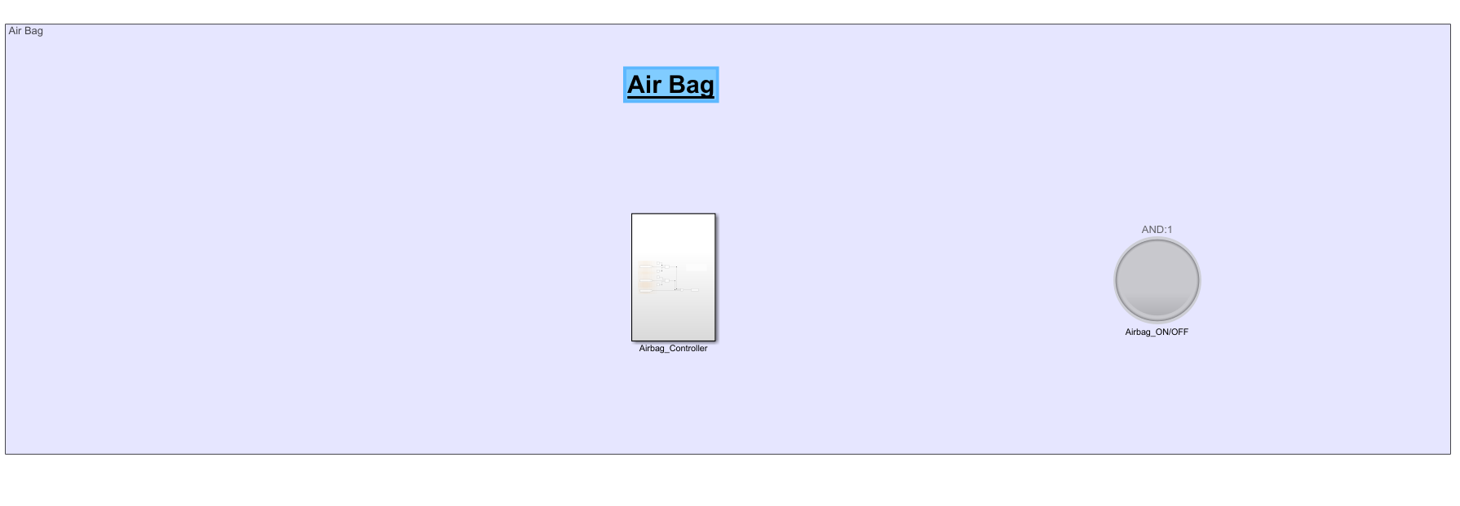



## **Cruise control**

**Input Model**

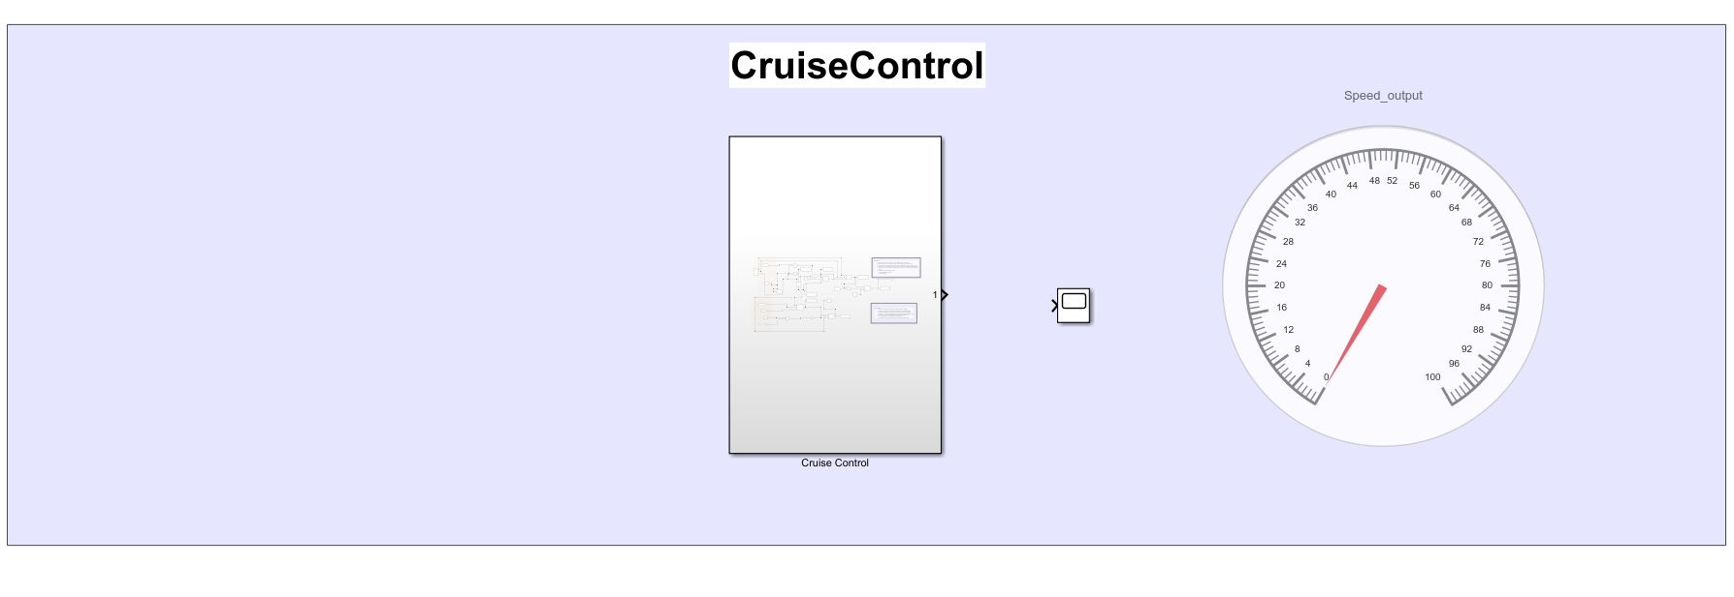

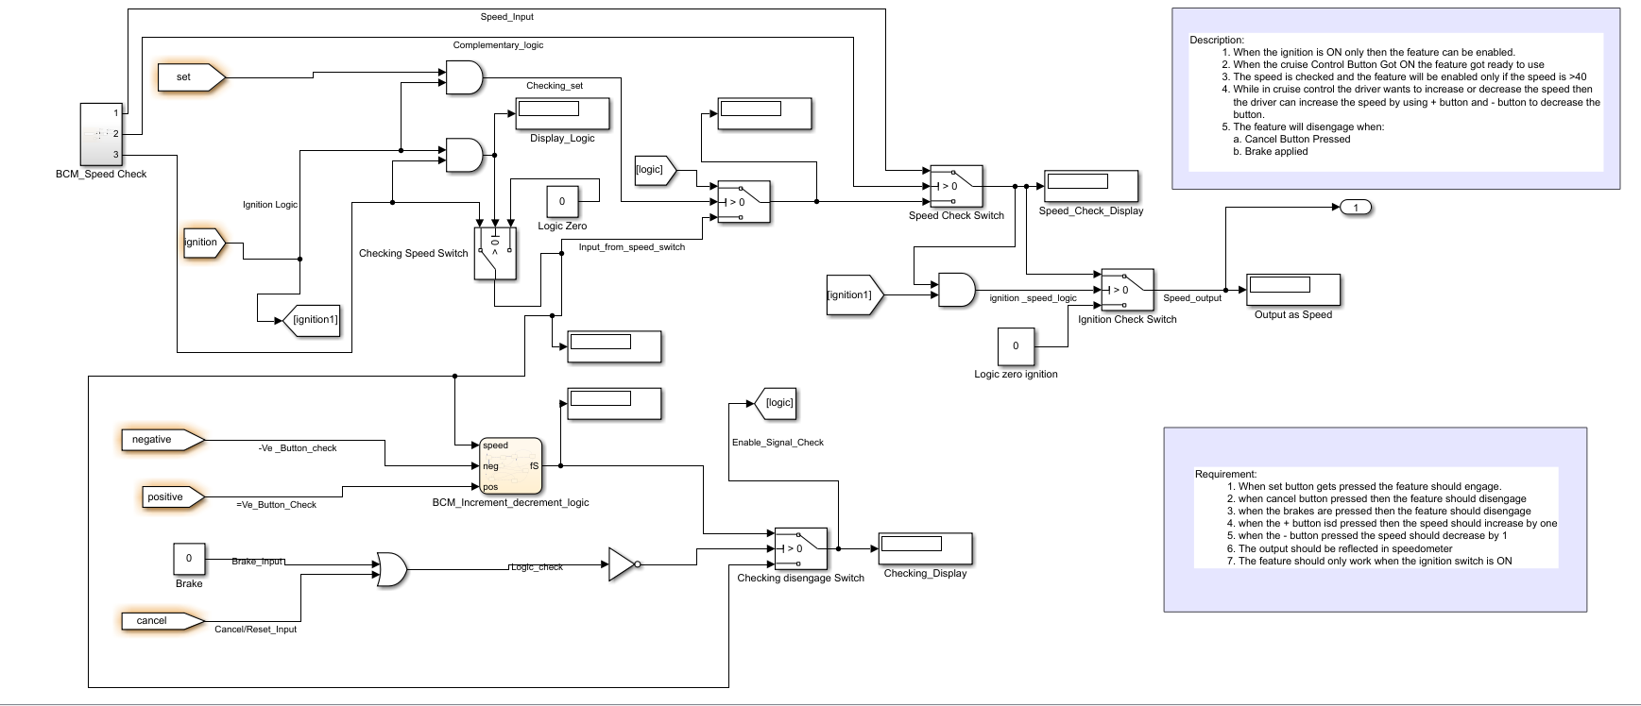

**jc_0796: Length restriction for State flow data names**

Sub ID a

State flow data {name} shall be a maximum of 63 characters.

**jc_0791: Duplicate data name definitions**

Sub ID a

Data name definitions shall not be duplicated in the base workspace and model workspace.

Sub ID b

Data names shall not be duplicated in the base workspace and data dictionary (sldd).

Sub ID c

Data name definitions shall not be duplicated in the model workspace and data dictionary (sldd).

**jc_0700: Unused data in State flow block**

Sub ID a

Configuration parameter [Unused data, events, messages, and functions](https://www.mathworks.com/help/simulink/gui/unused-data-events-and-messages.html) shall be set to Warning or Error to prevent unused State flow® data, events, and messages in the State flow block.

**jc_0011: Optimization parameters for Boolean data types**

Sub ID a

Configuration parameter [Implement logic signals as Boolean data (vs. double)](https://www.mathworks.com/help/simulink/gui/implement-logic-signals-as-boolean-data-vs-double.html) shall be selected so that optimization parameters are activated for logic signals.

**jc_0792: Unused Data**

Sub ID a

The data dictionary (sldd) shall define only the data that is used in the Simulink® or State flow® Coder™ model.

Sub ID b

The model workspace shall define only the data that is used in the Simulink or State flow model.

**Output Model**

